***Cloud computing***

***Migrating a Database to Amazon RDS***

***Task 1: Creating an RDS instance***

***Summary:  
I created a managed MariaDB instance using Amazon RDS to replace the self-hosted database on the EC2 instance. We chose this approach to improve database reliability, automate backups, and reduce manual maintenance work.***

***Explanation:  
We configured the instance with the identifier CafeDatabase, used admin as the username, and set a secure password. I selected a lightweight instance type (db.t3.micro) and allocated 20 GiB of SSD storage. The instance was placed in the lab VPC and subnet group with restricted access via the dbSG security group. Public access was disabled for security. This setup gave us a scalable, durable foundation to migrate the café’s database.***

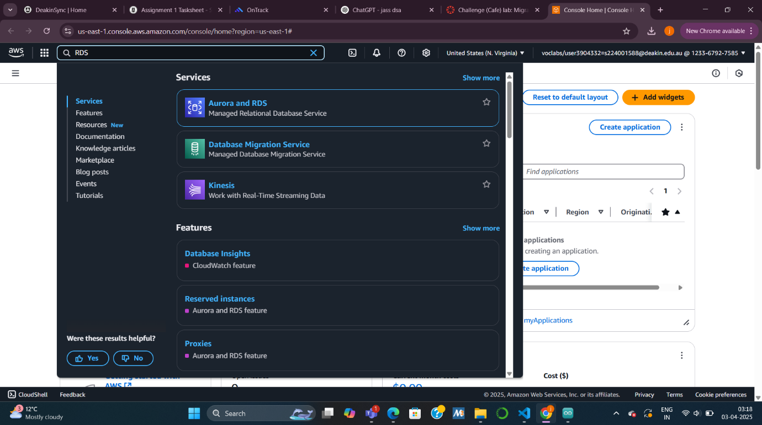

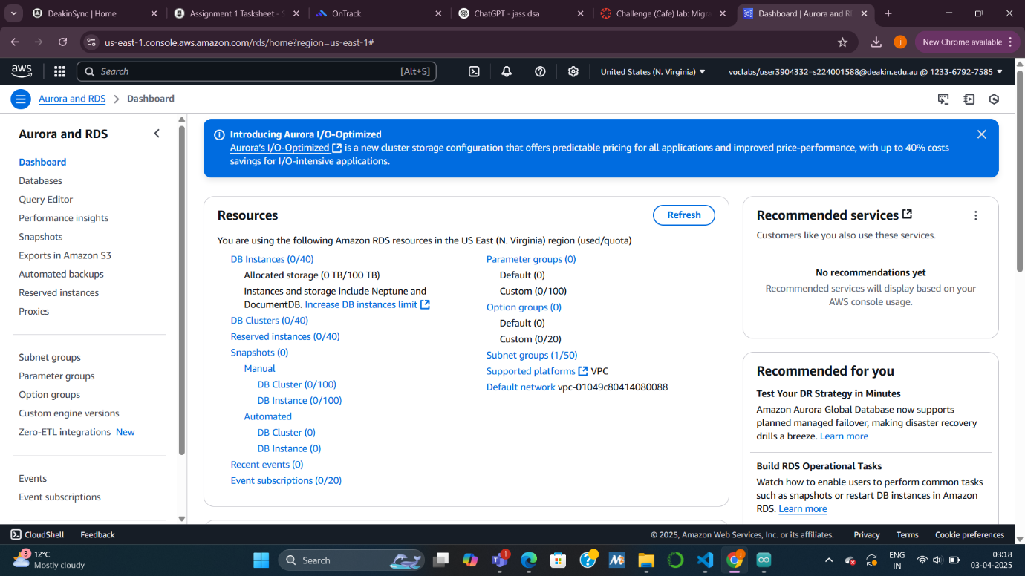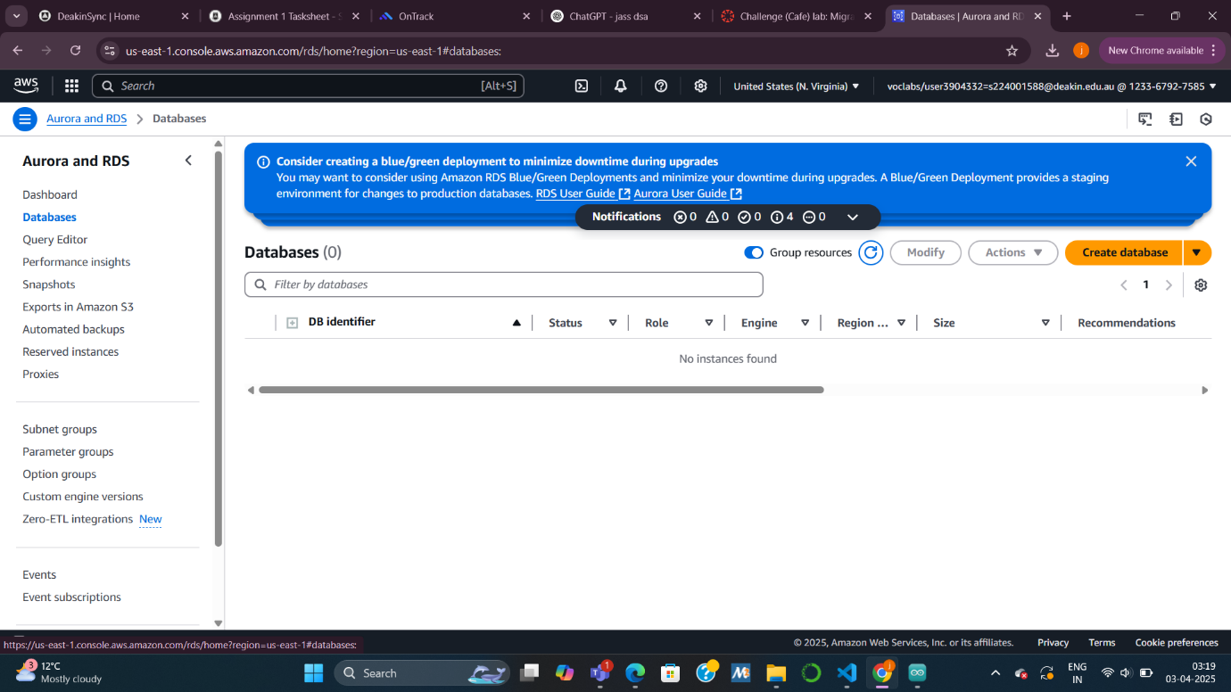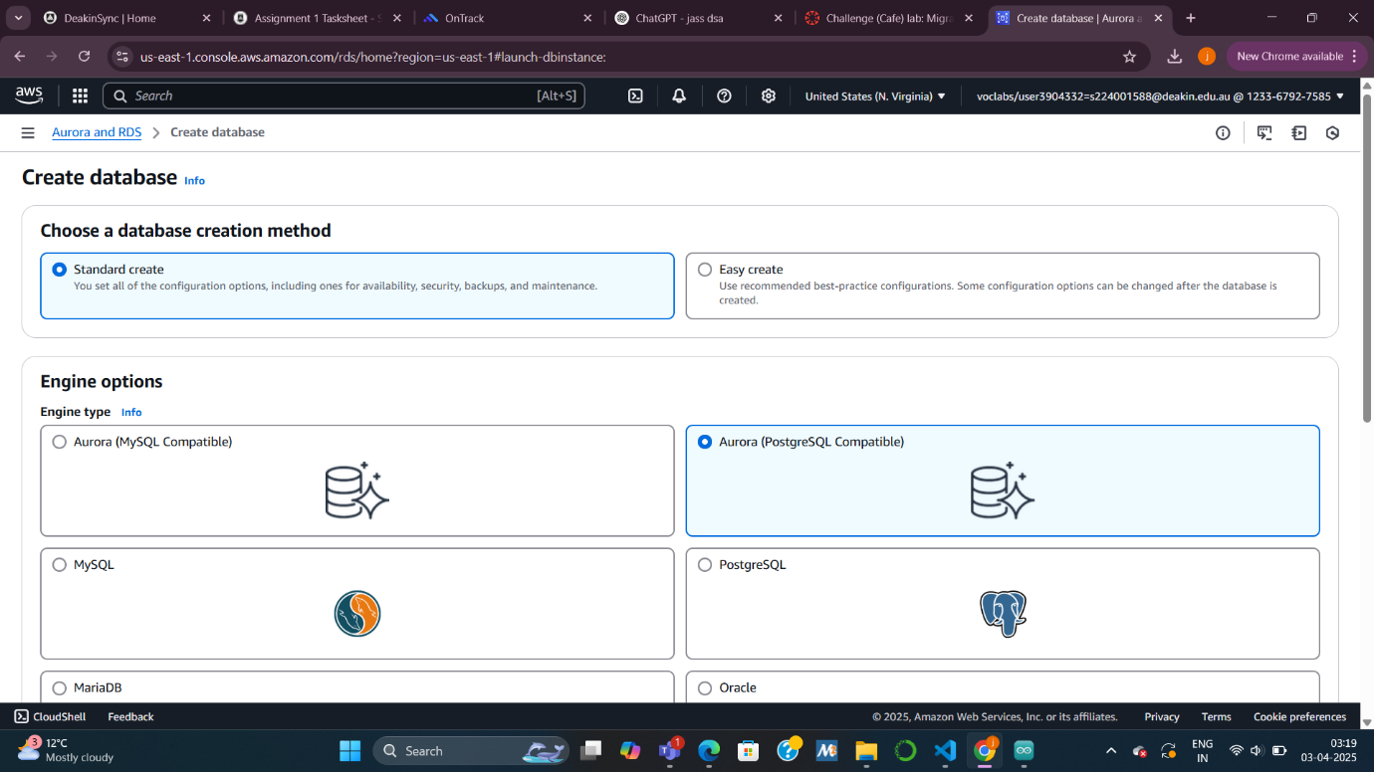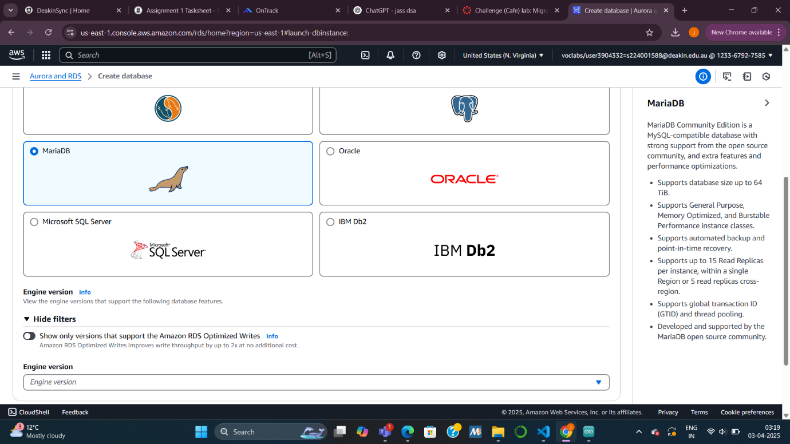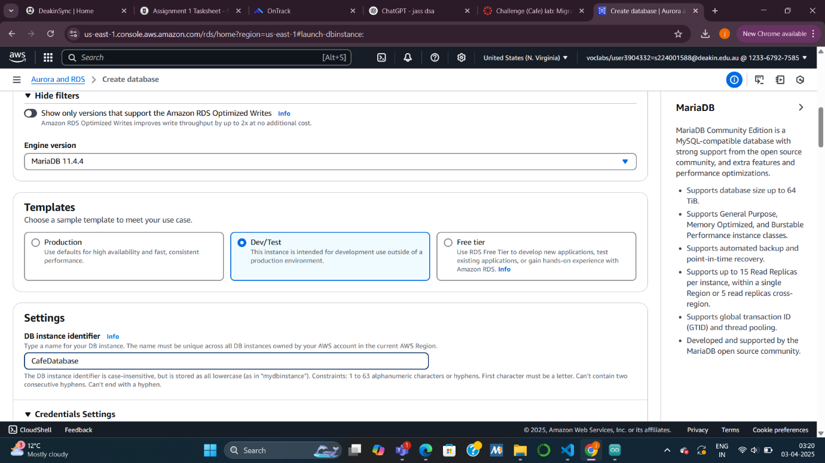

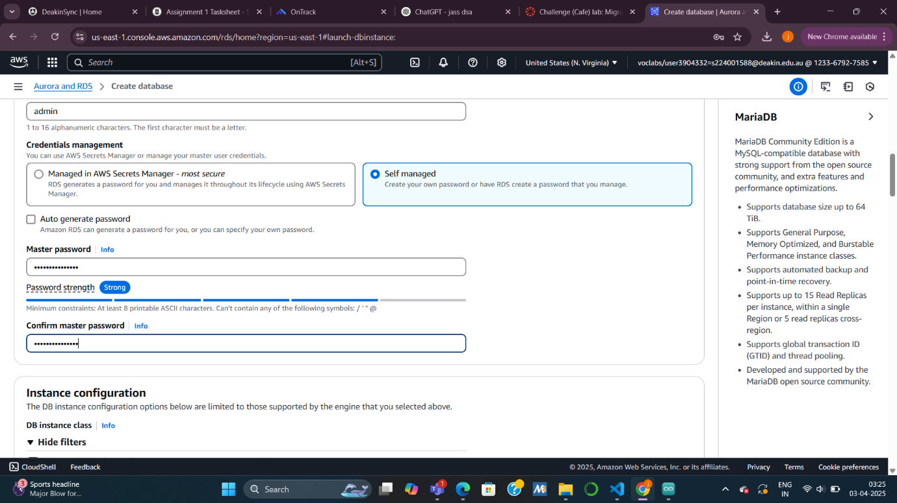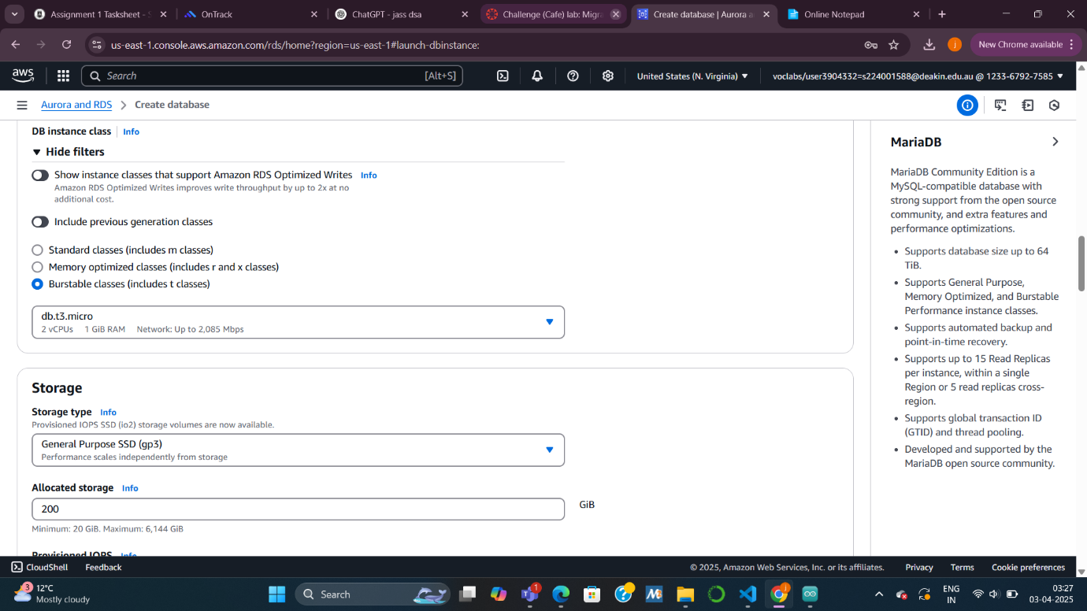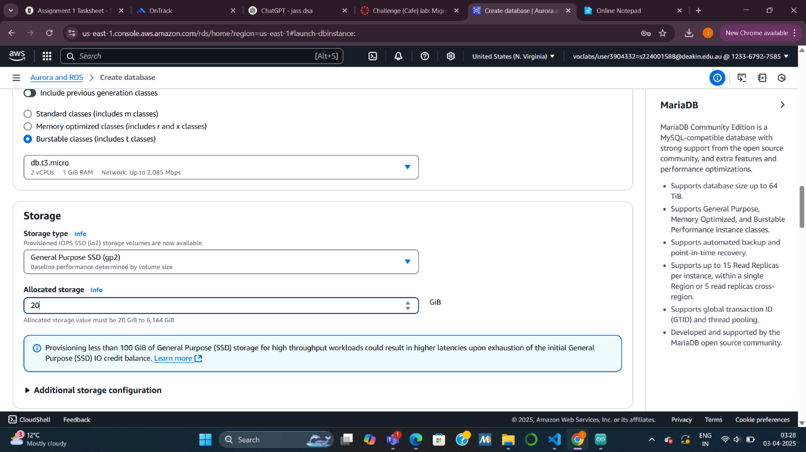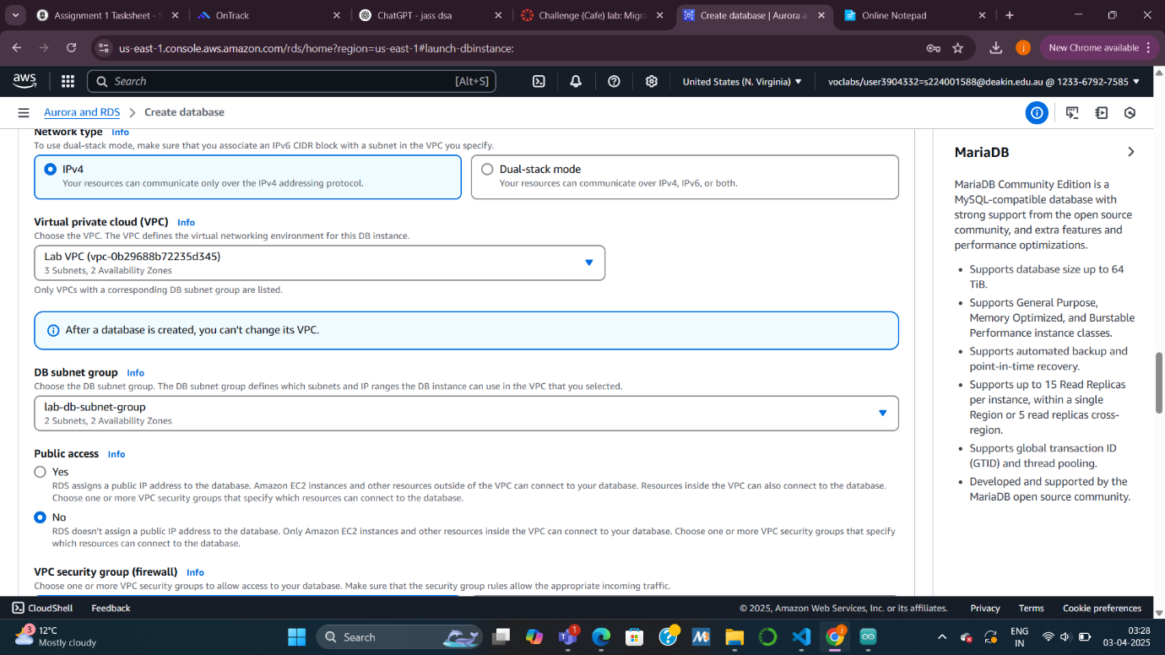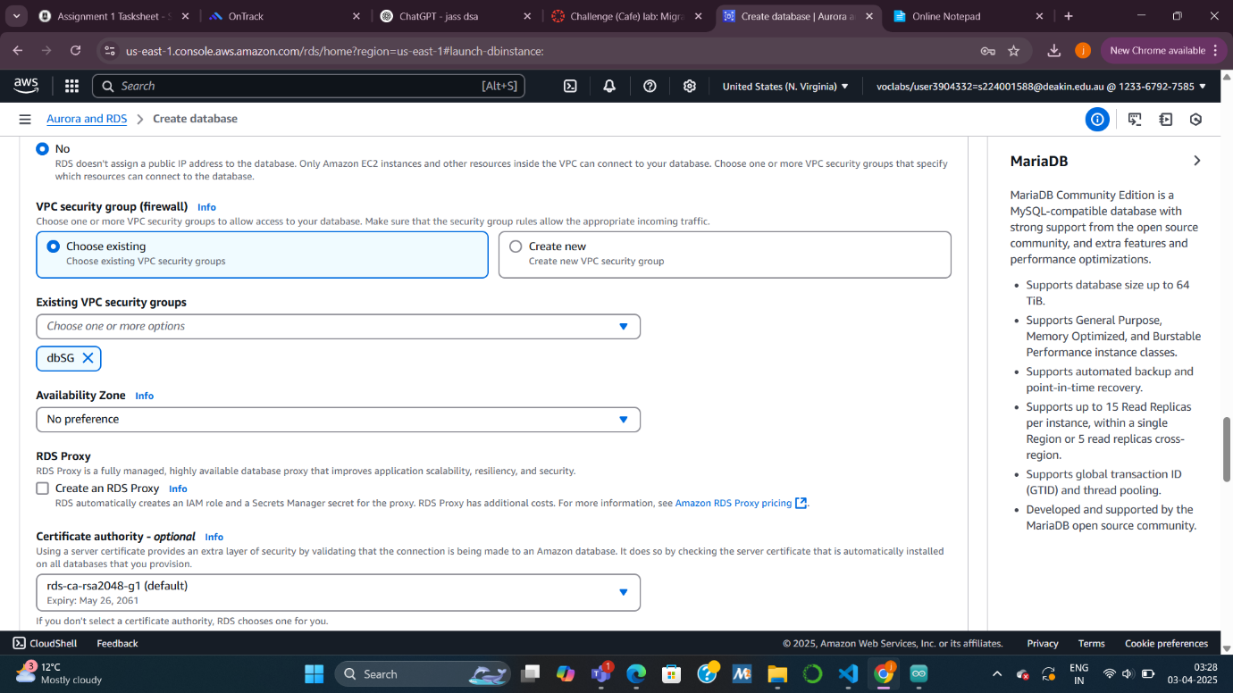

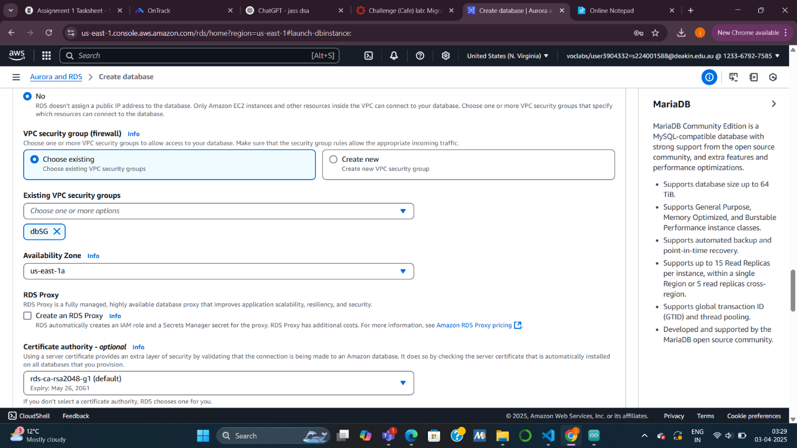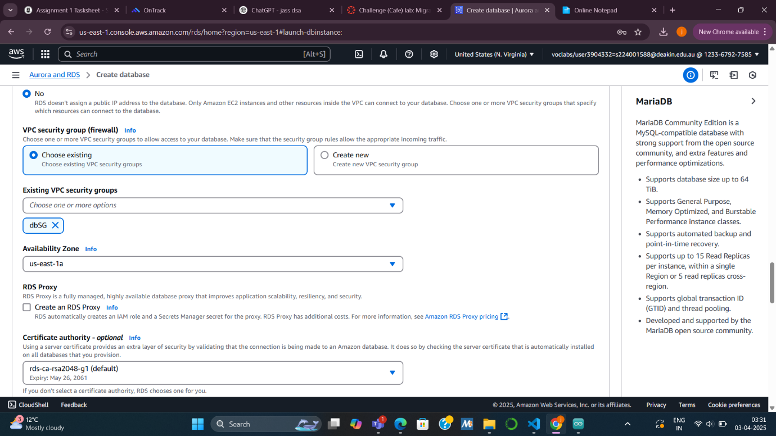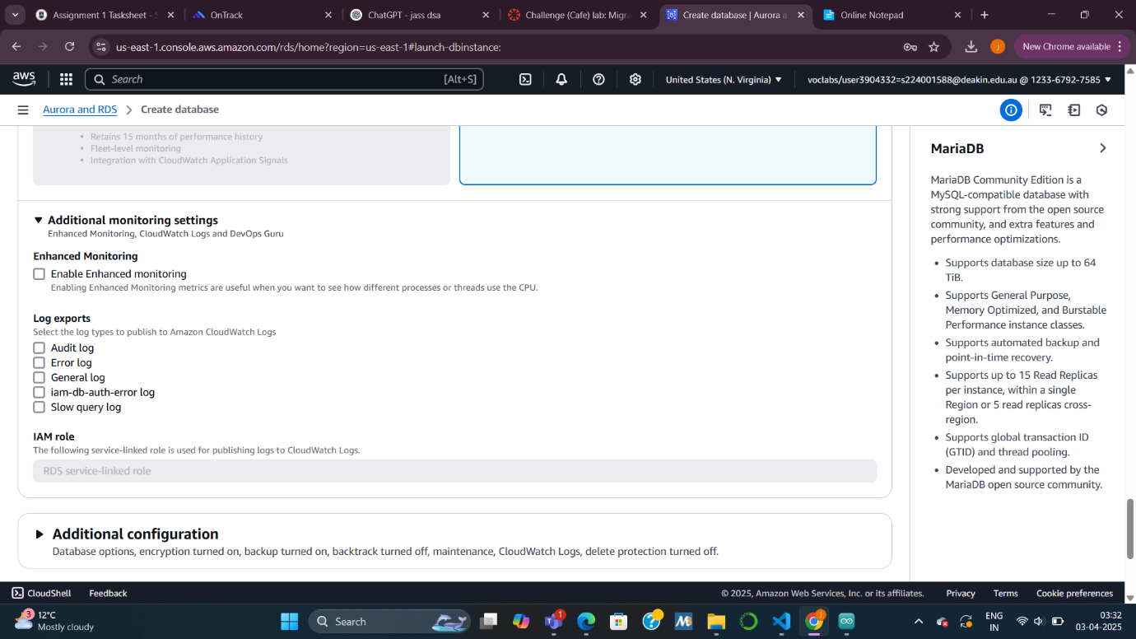

***Task 2: Analyzing the existing café application deployment***

***Summary:  
I verified that the current café web application was running correctly on an EC2 instance by placing a test order and reviewing the order history. Then, I connected to the EC2 instance using AWS Systems Manager to prepare for the database export.***

***Explanation:  
We used the public IP of the EC2 instance to load the app and confirm that it stores order data properly. After that, I accessed the instance terminal through Session Manager, which allowed me to work on the server without using SSH keys. This connection set me up for working directly with the local MariaDB database.***

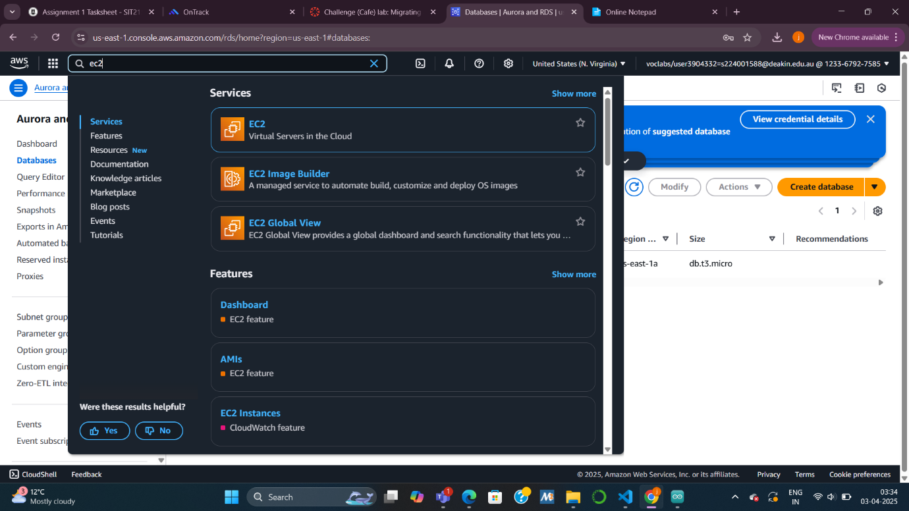

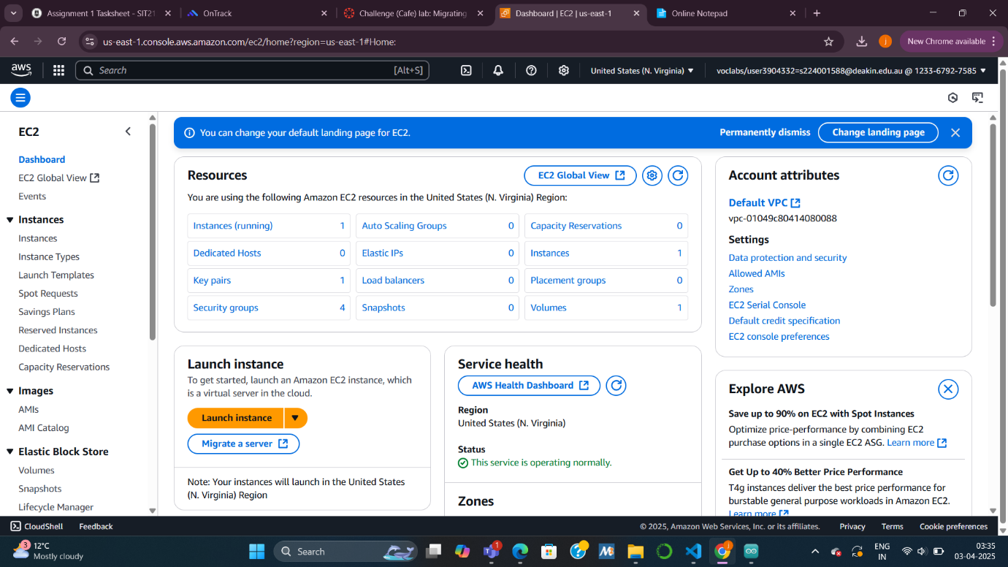

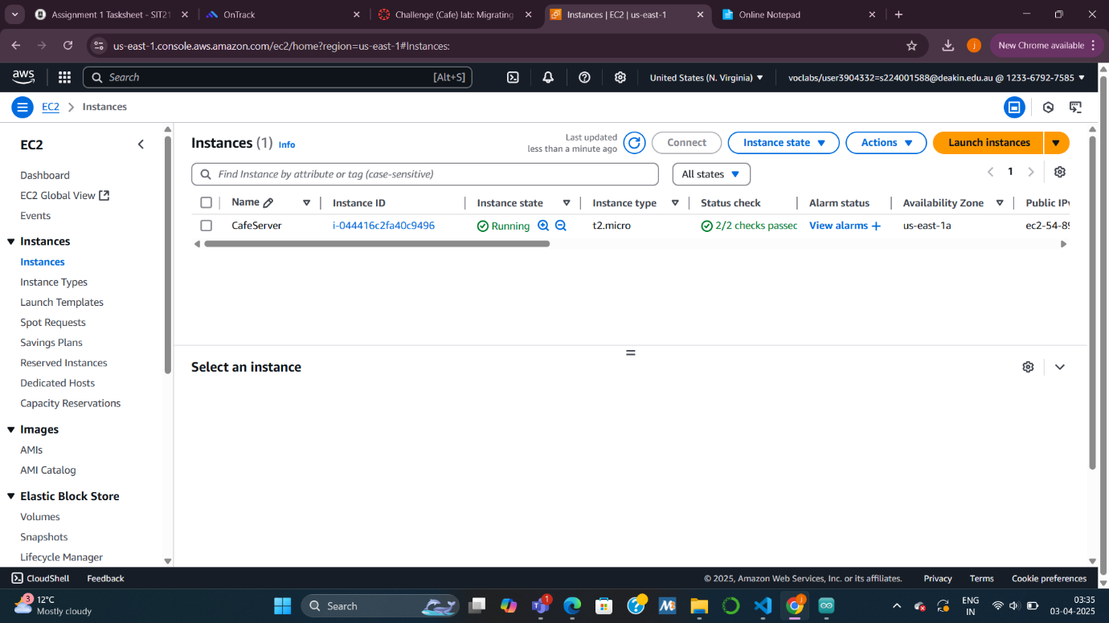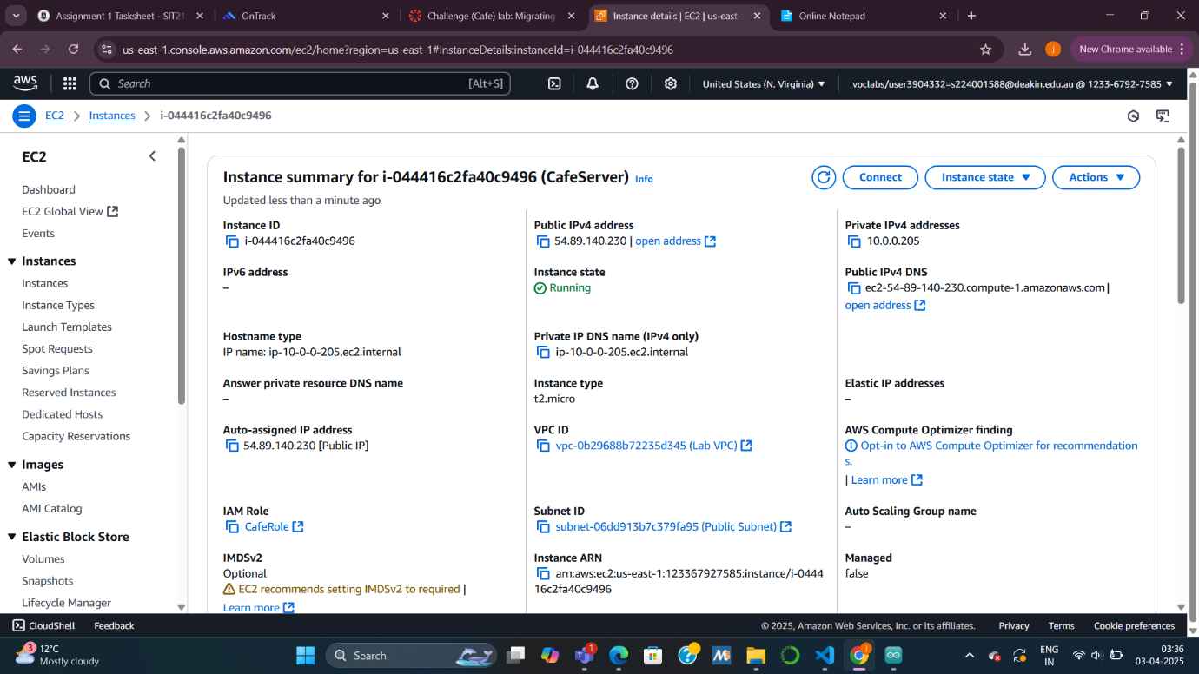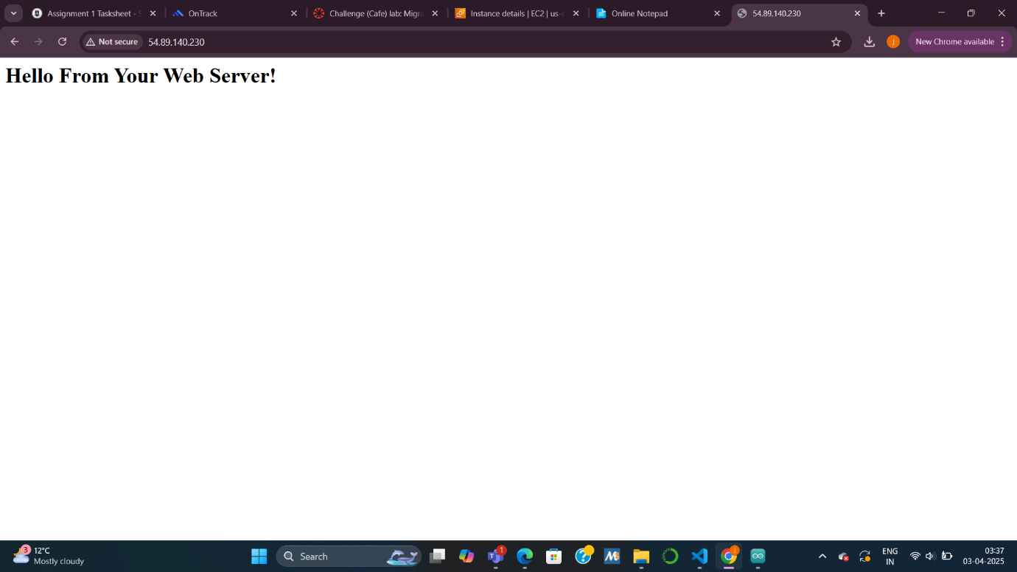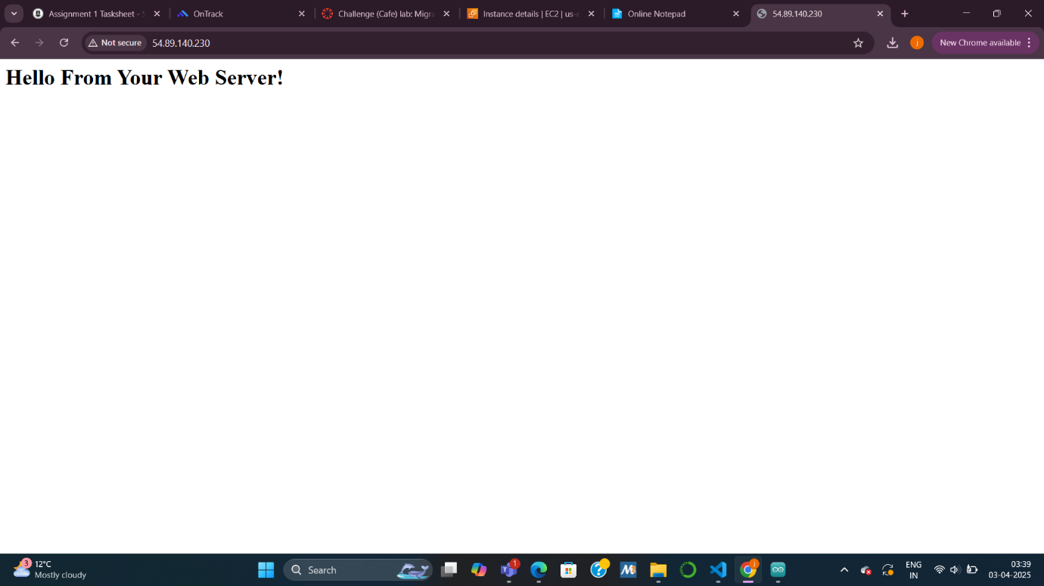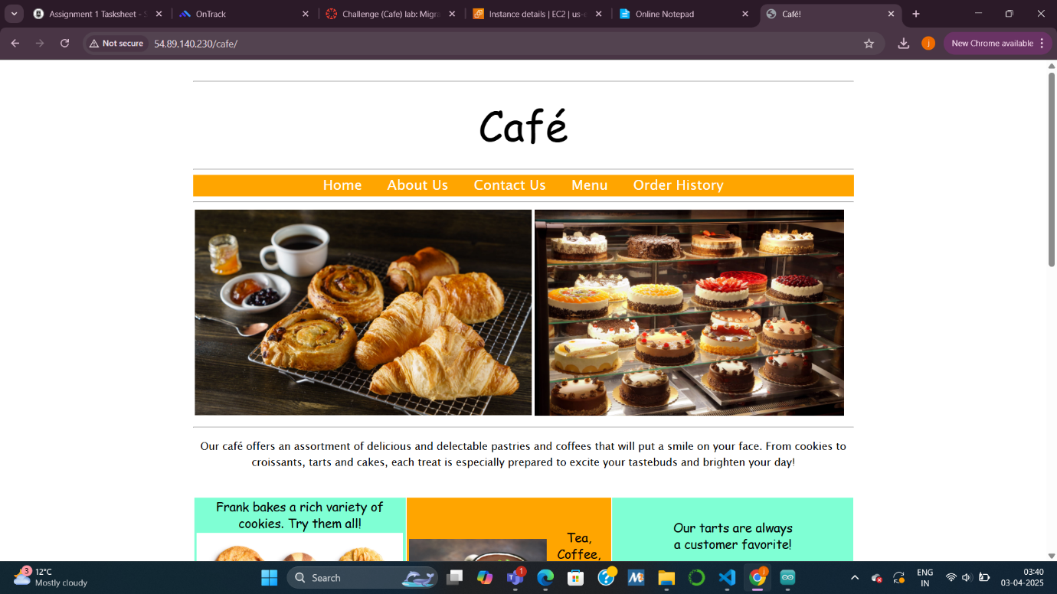

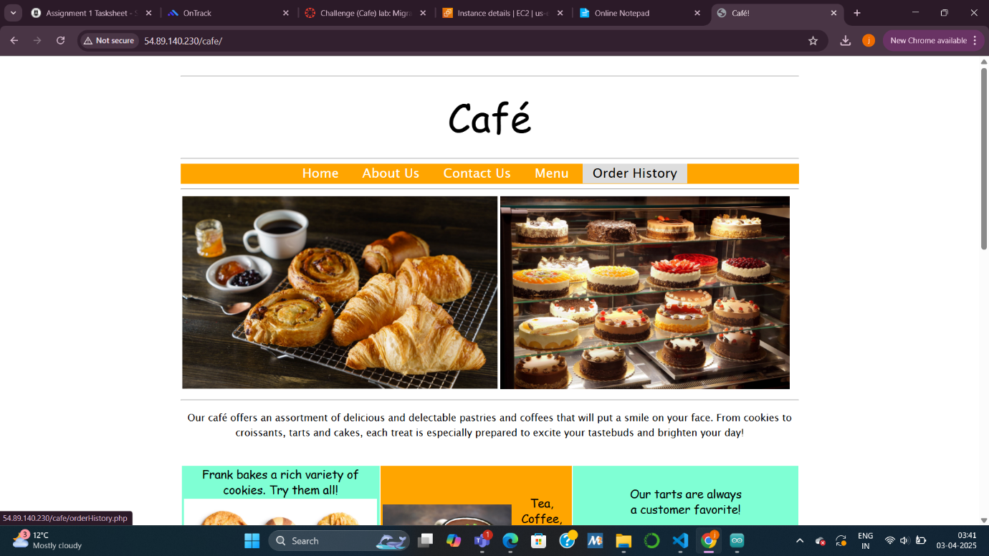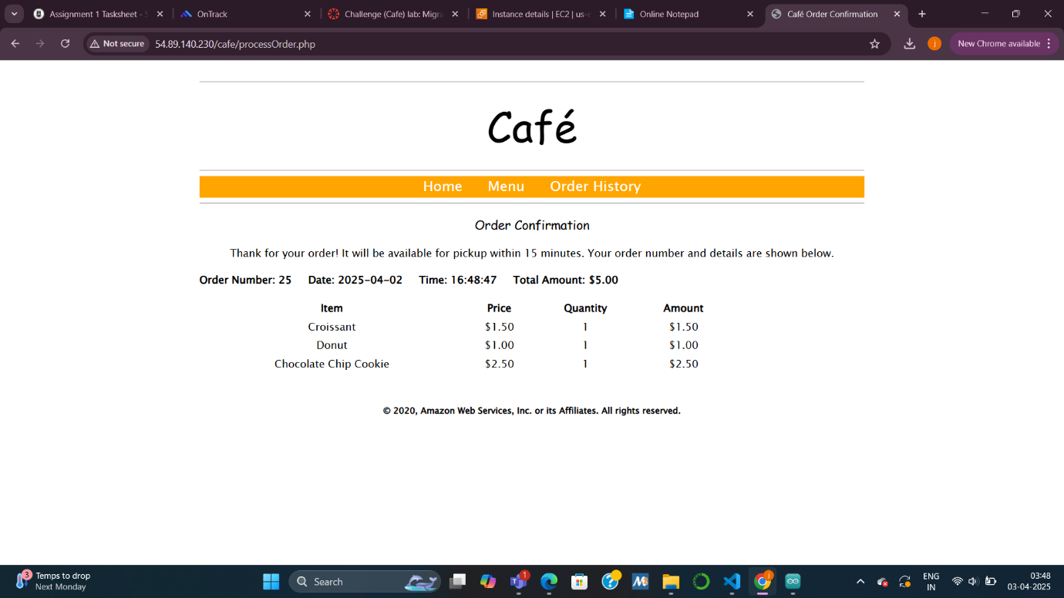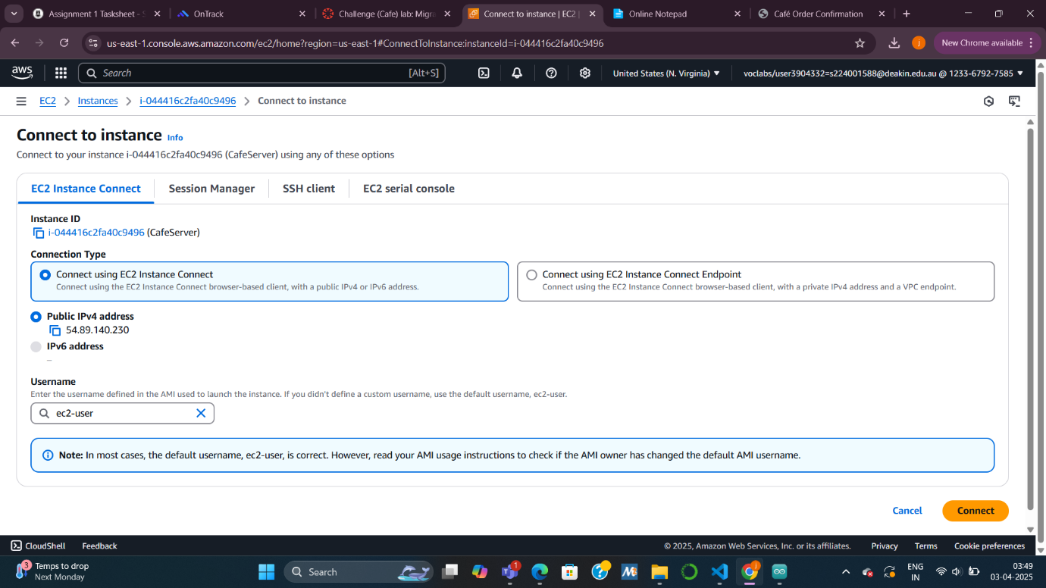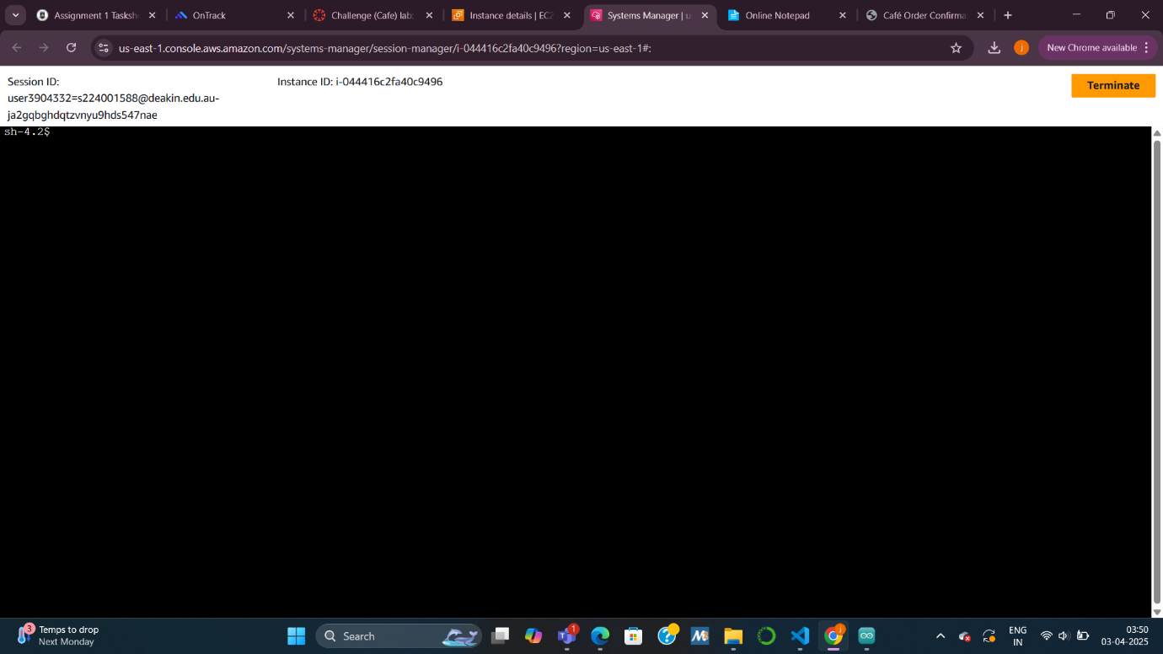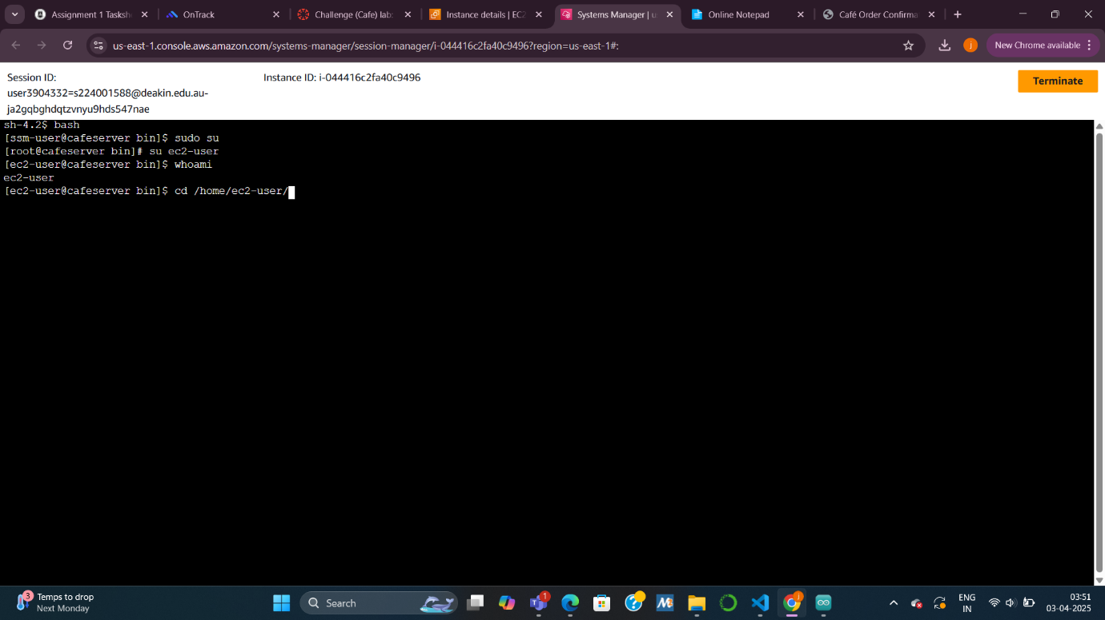

***Task 3: Exporting data from EC2 database***

***Summary:  
I connected to the local MariaDB database on the EC2 instance, reviewed its contents, and used mysqldump to export the café’s data into a SQL file for migration.***

***Explanation:  
We first checked that MariaDB was running and confirmed its version. I retrieved the root password securely from Secrets Manager and logged into the database. After reviewing the cafe_db tables and data, I ran the mysqldump command to generate CafeDbDump.sql. This file included all existing customer order data, ready to be imported into the new RDS instance.***

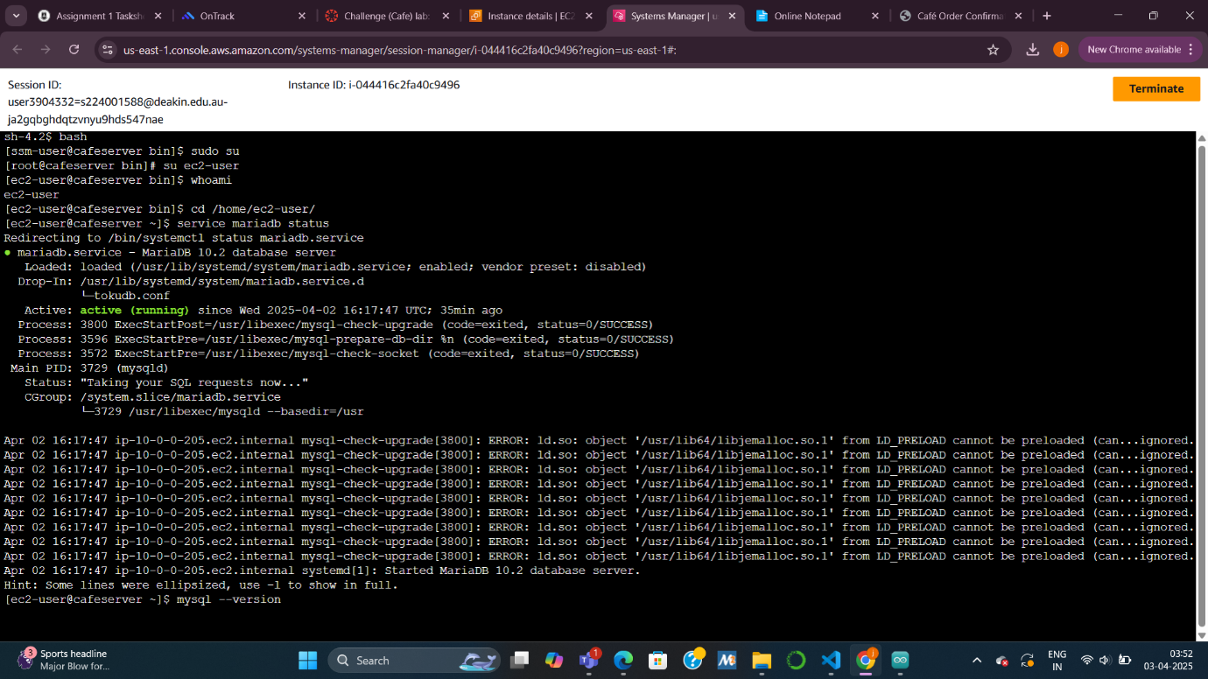

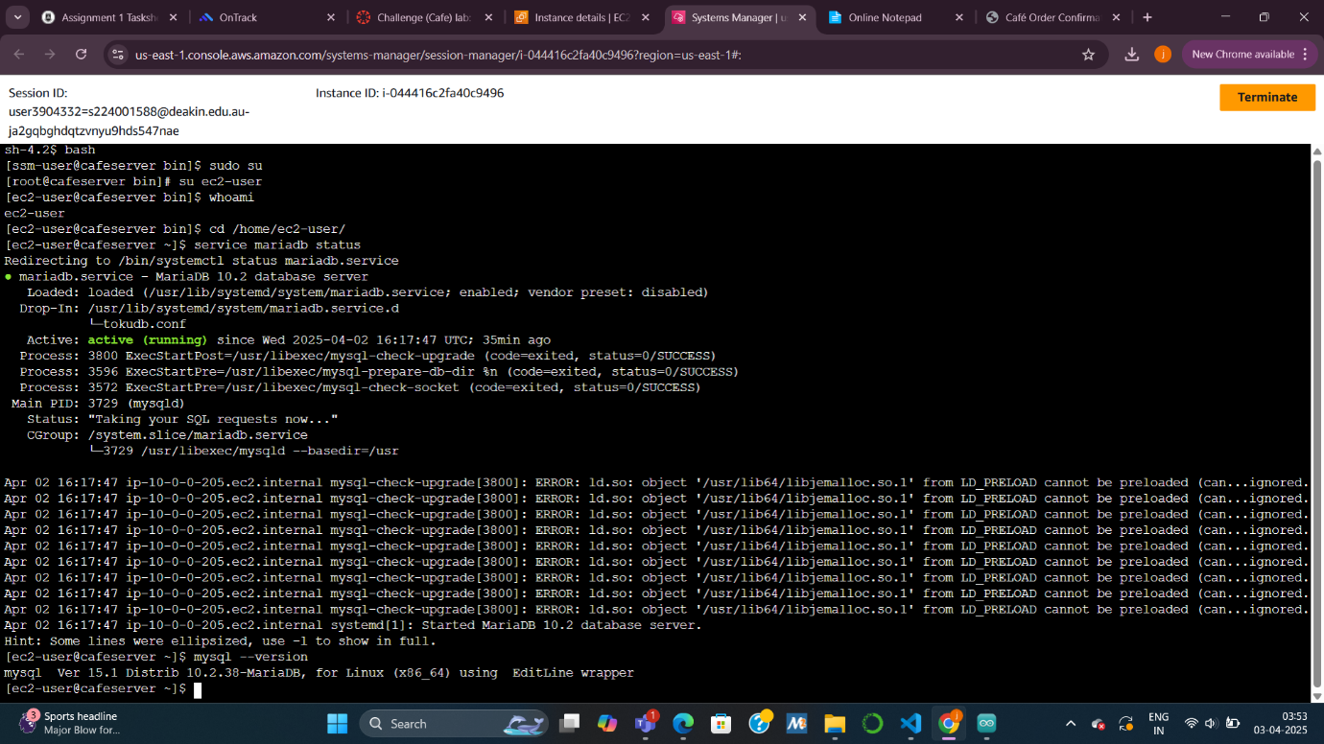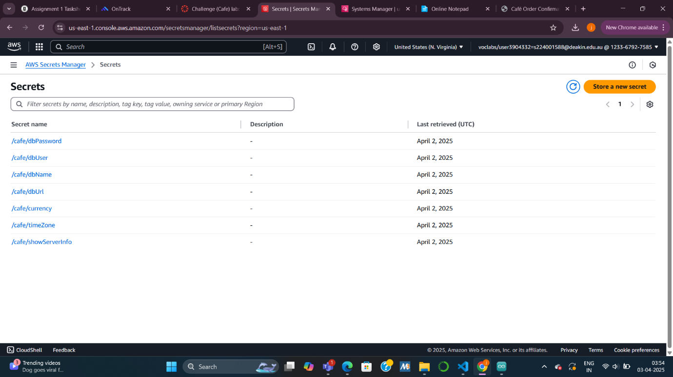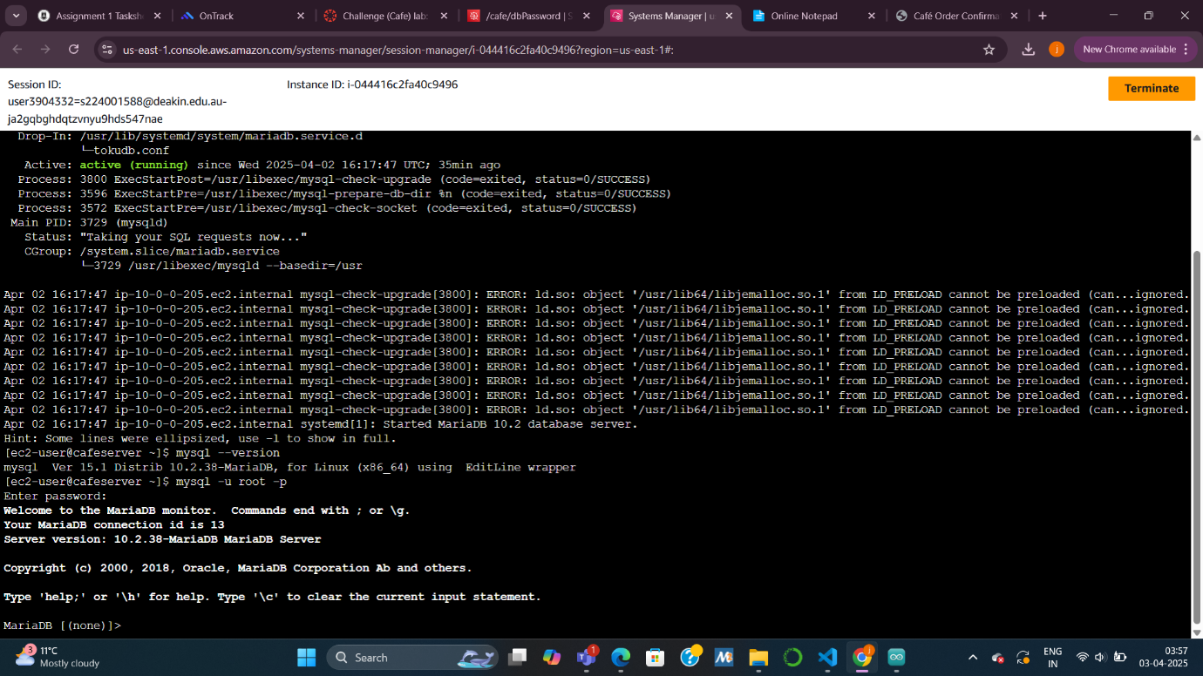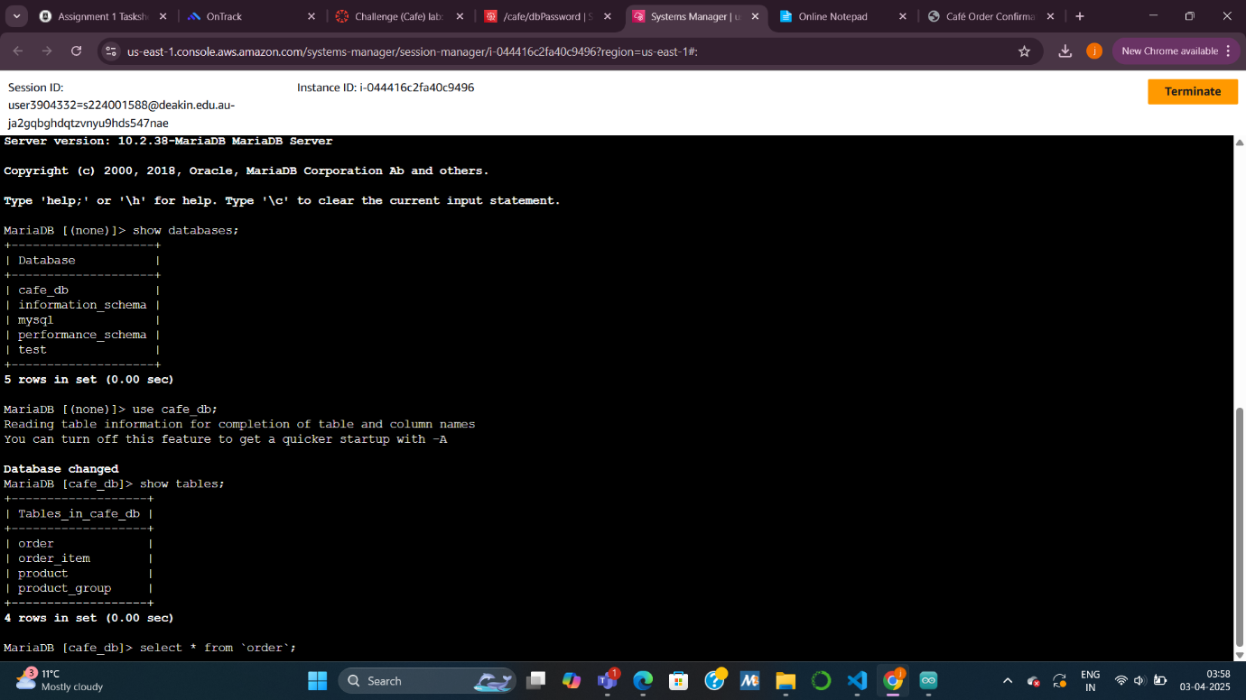

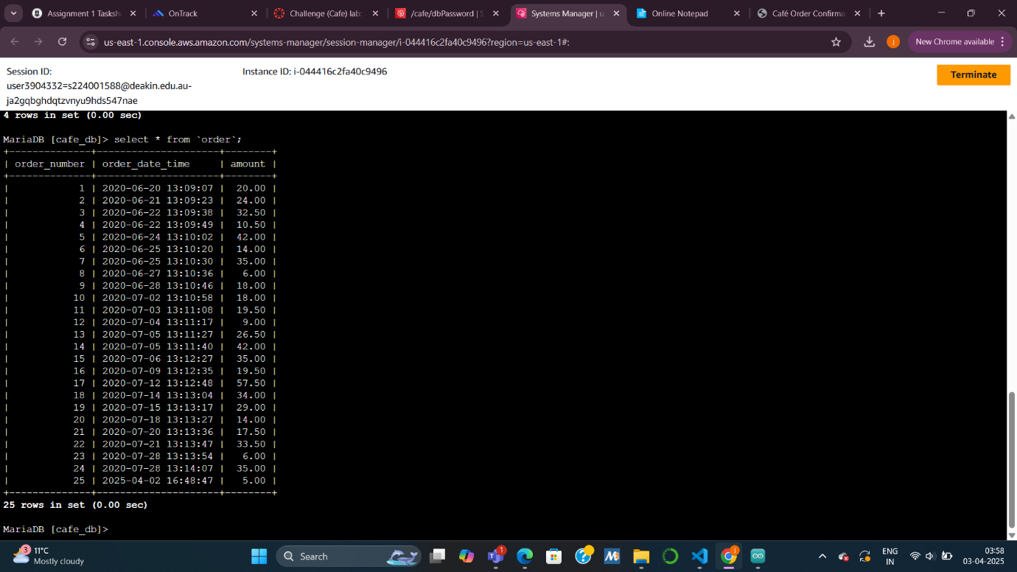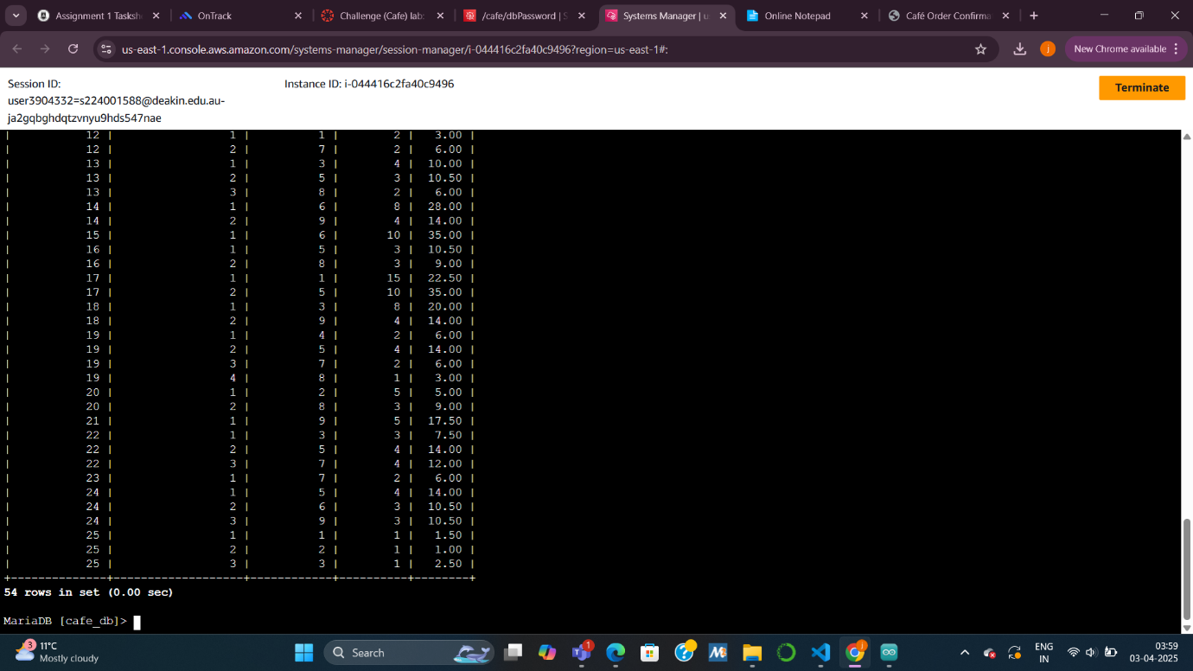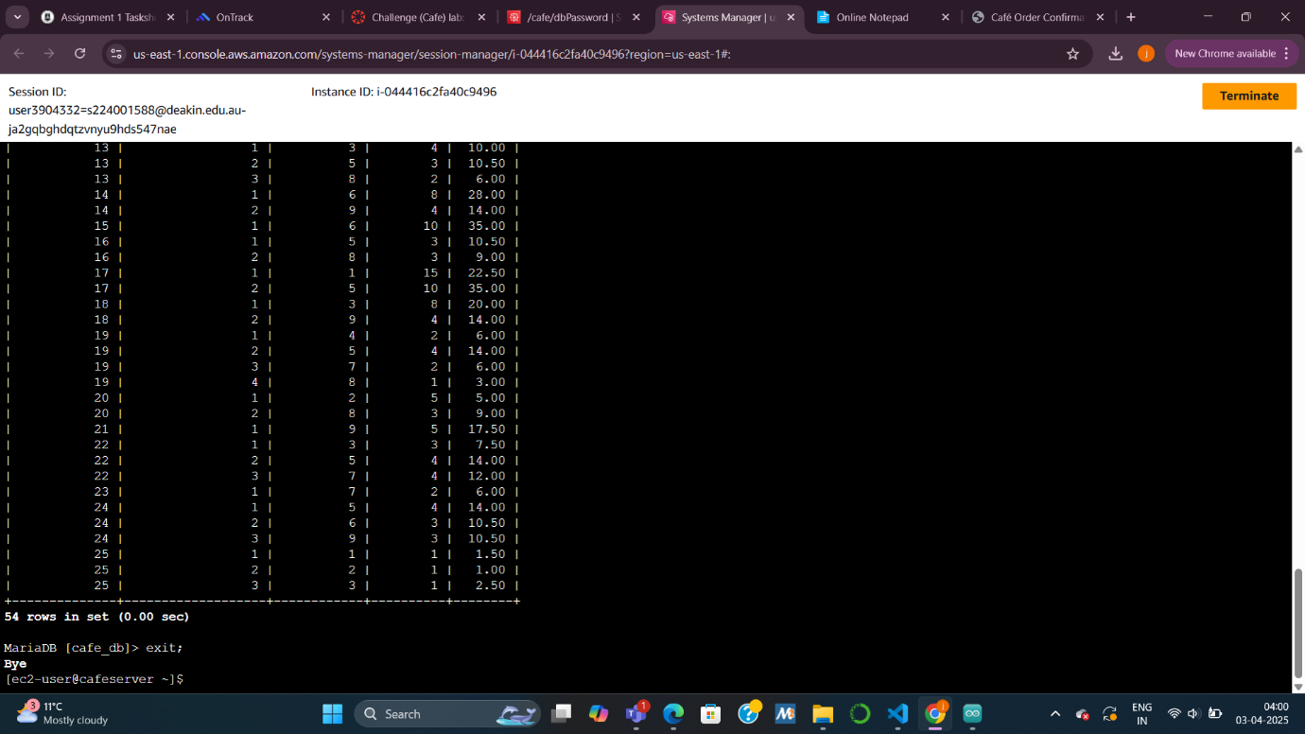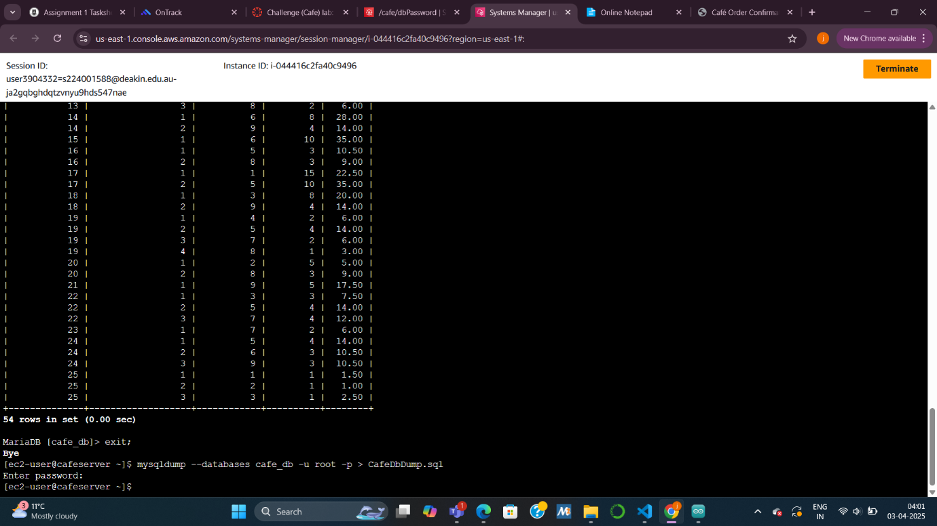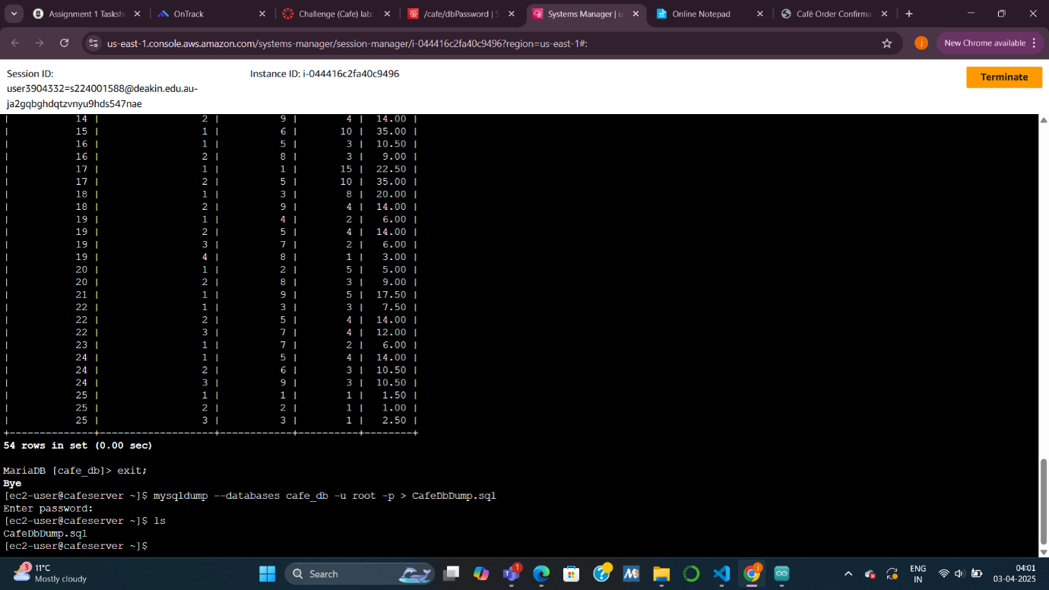

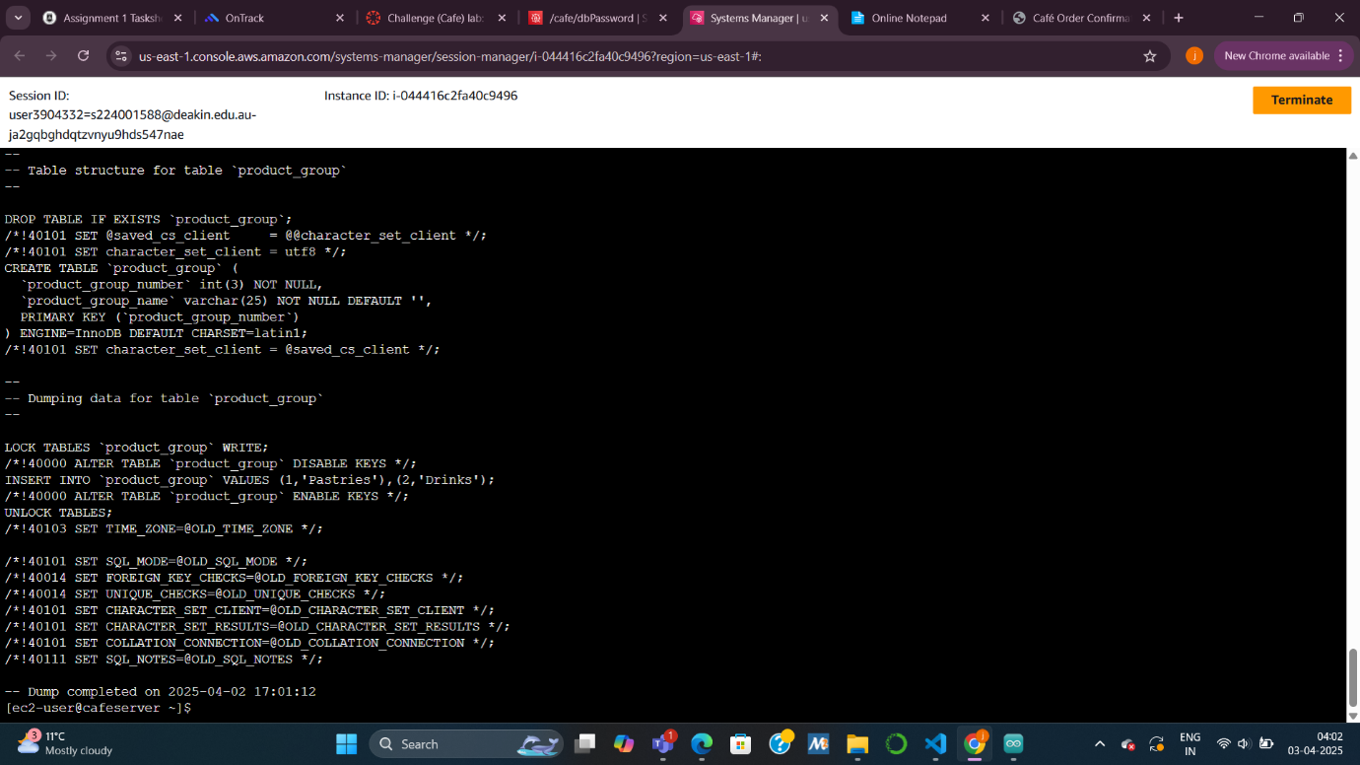

***Task 4: Connecting to the new RDS instance***

***Summary:  
I confirmed that the RDS instance was up and running, and then successfully connected to it from the EC2 instance to ensure everything was correctly configured.***

***Explanation:  
We checked the instance status and details such as subnet and security groups to answer lab questions. From the EC2 terminal, I used the MySQL client to connect to the RDS endpoint using the admin credentials. At this point, we confirmed network connectivity, although the RDS database was still empty (as expected).***

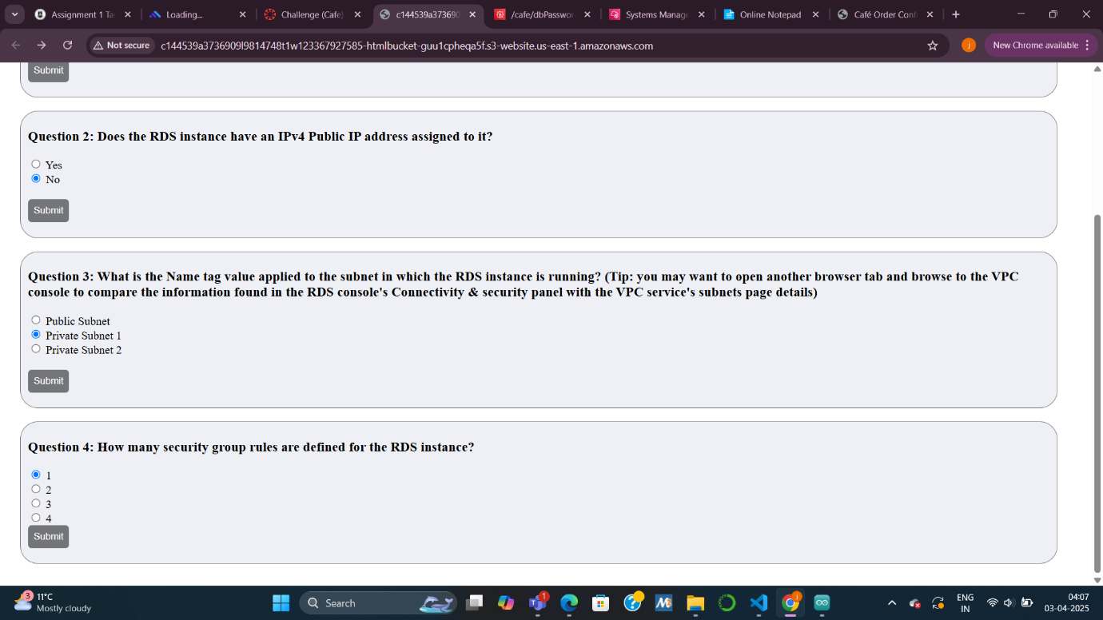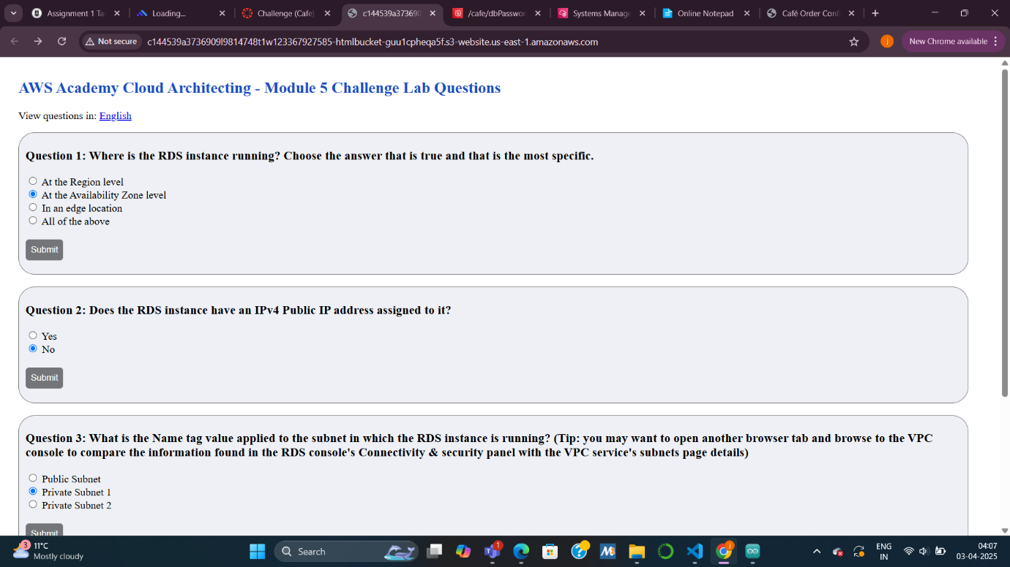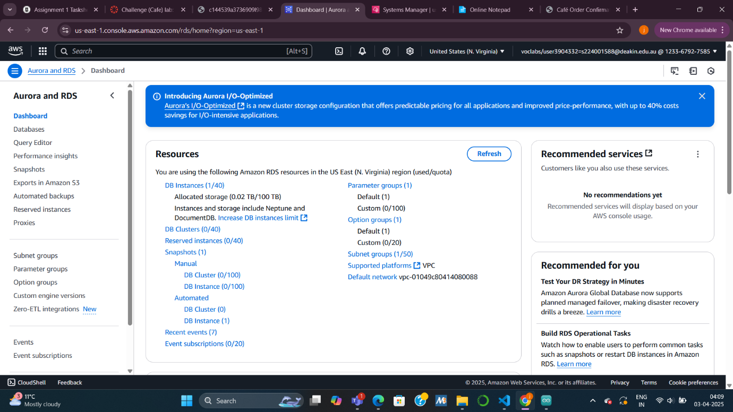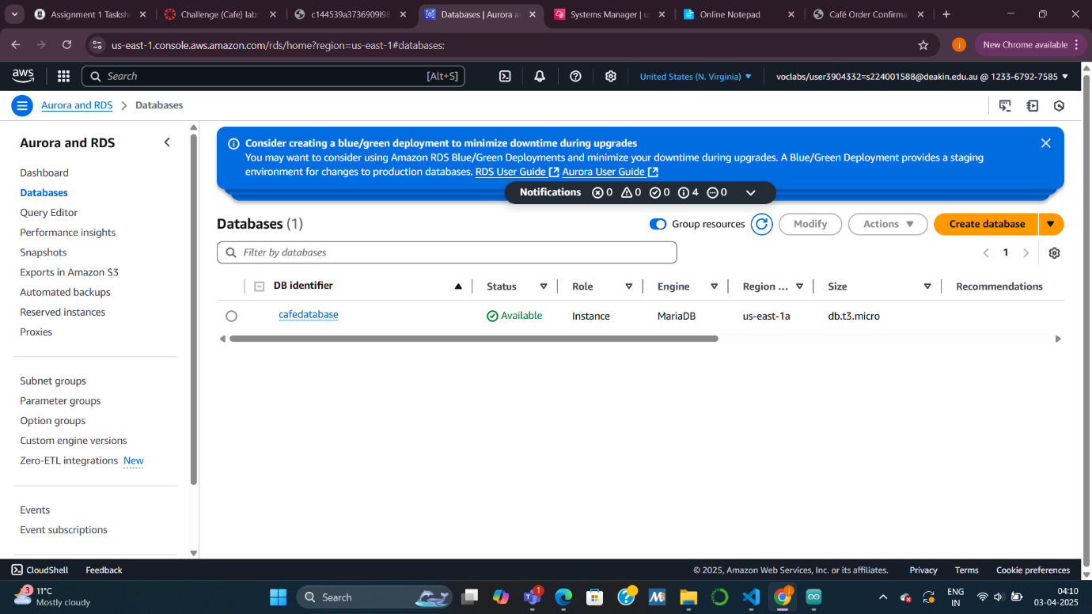

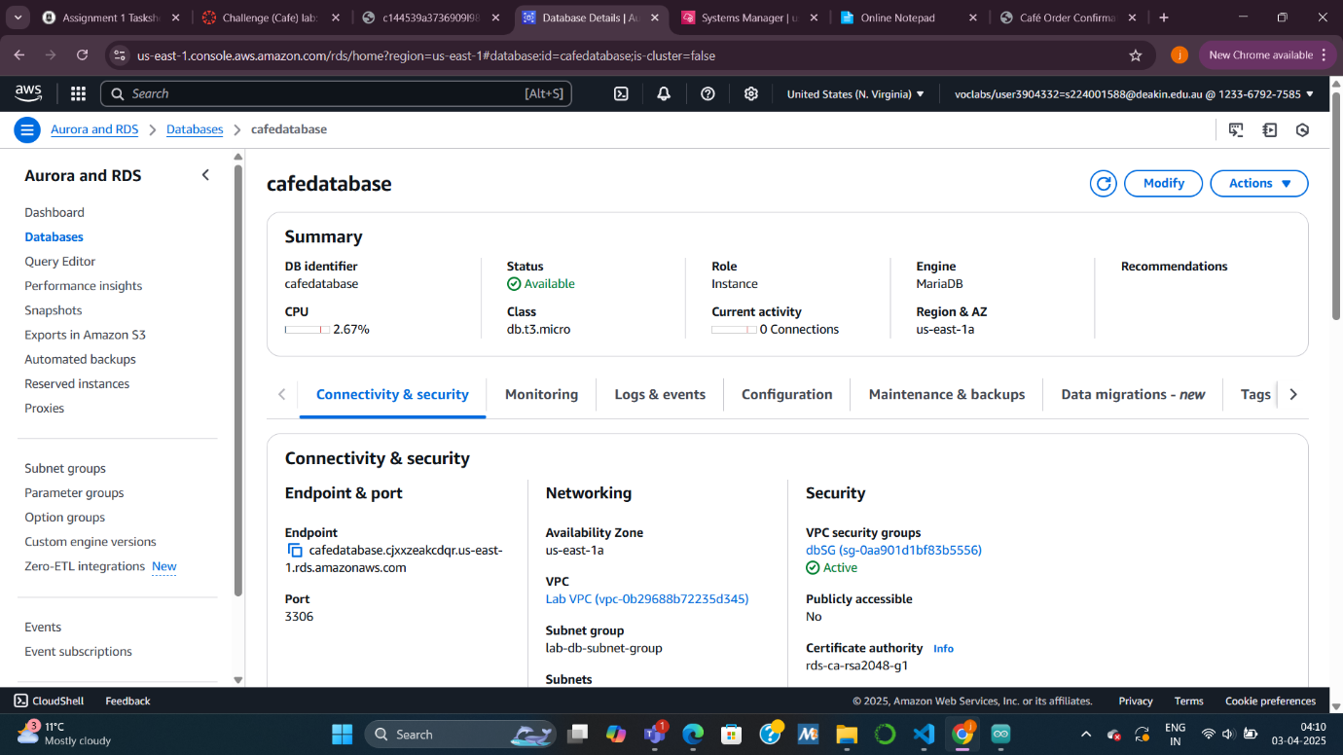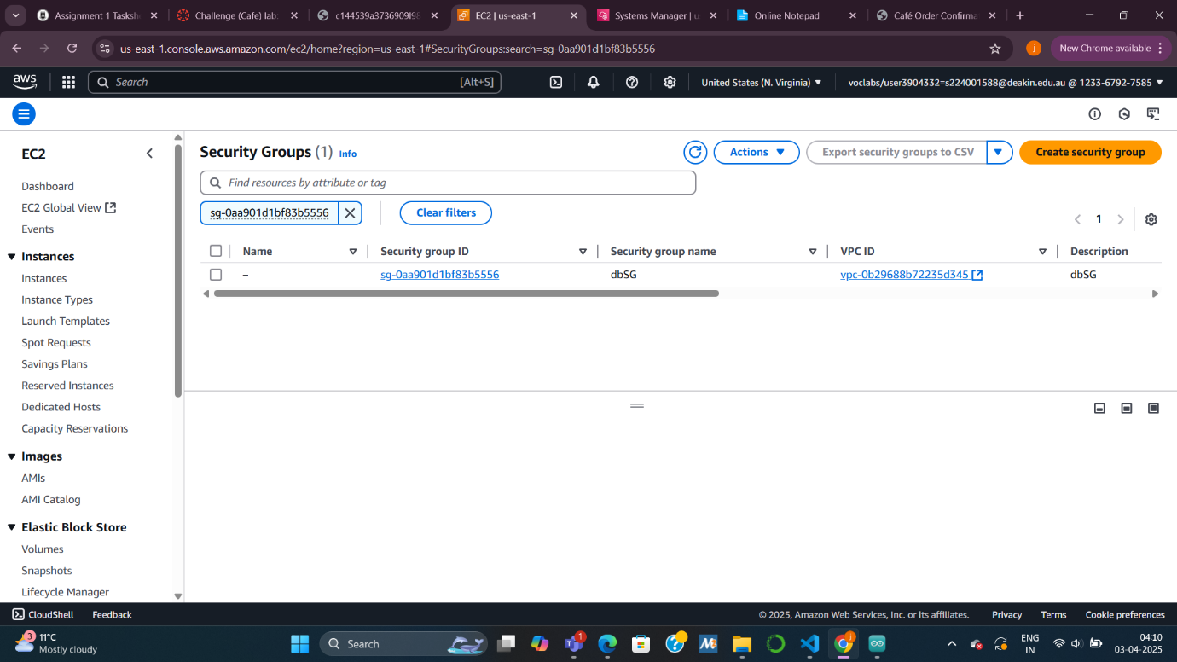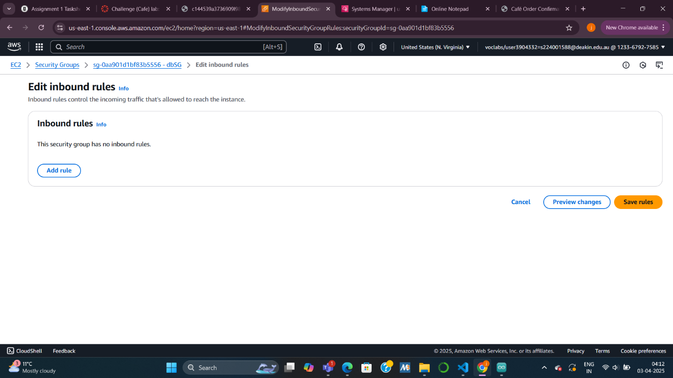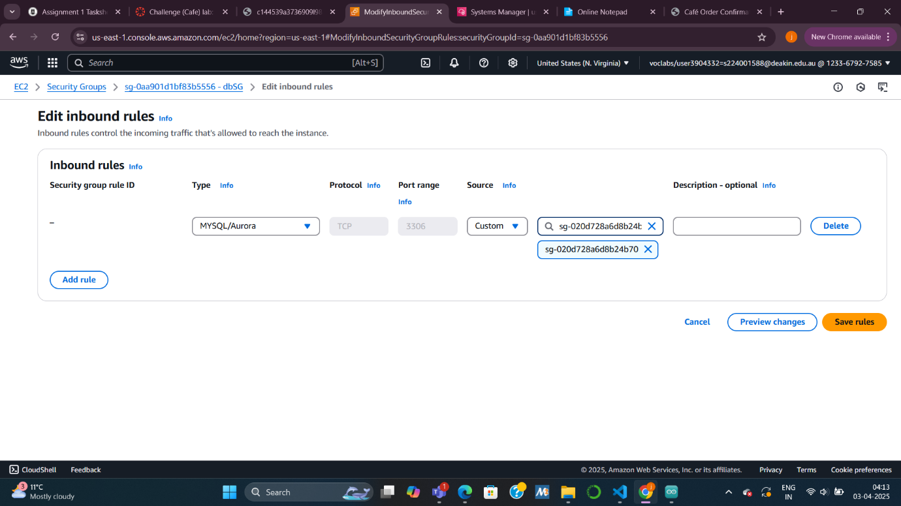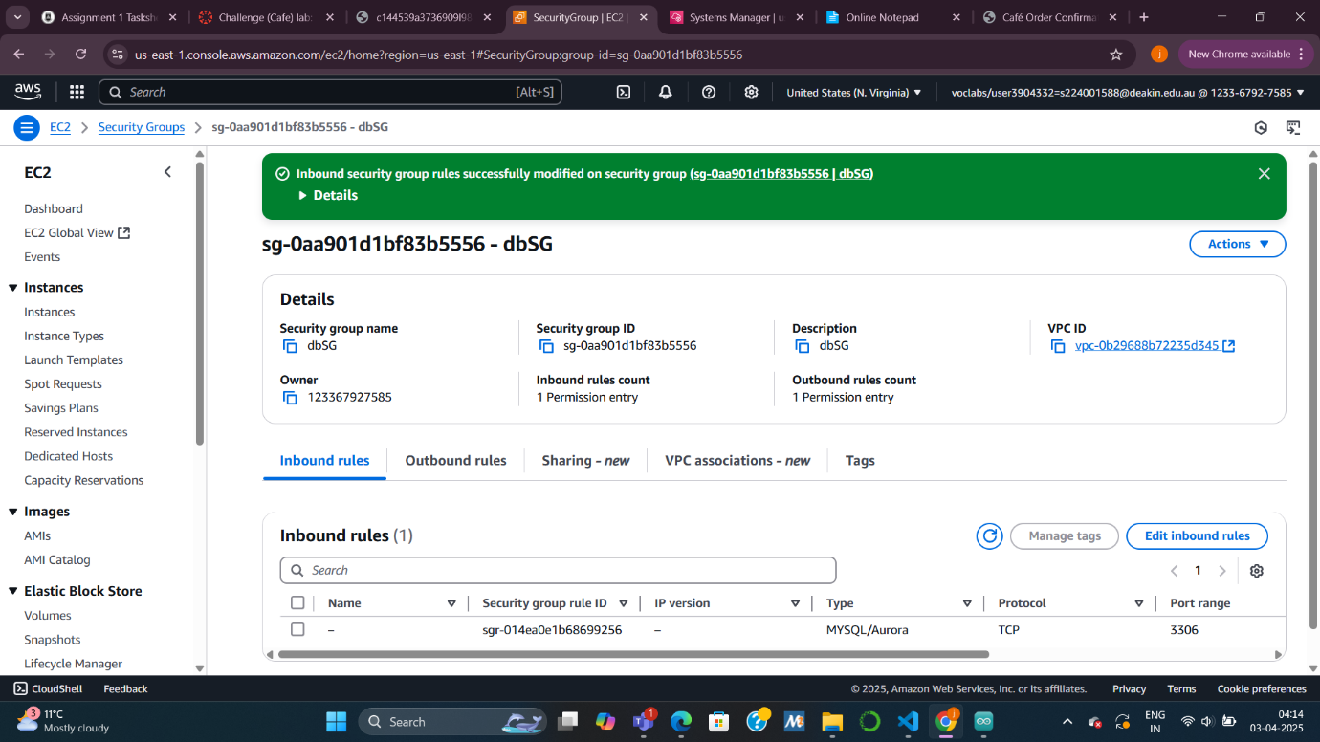

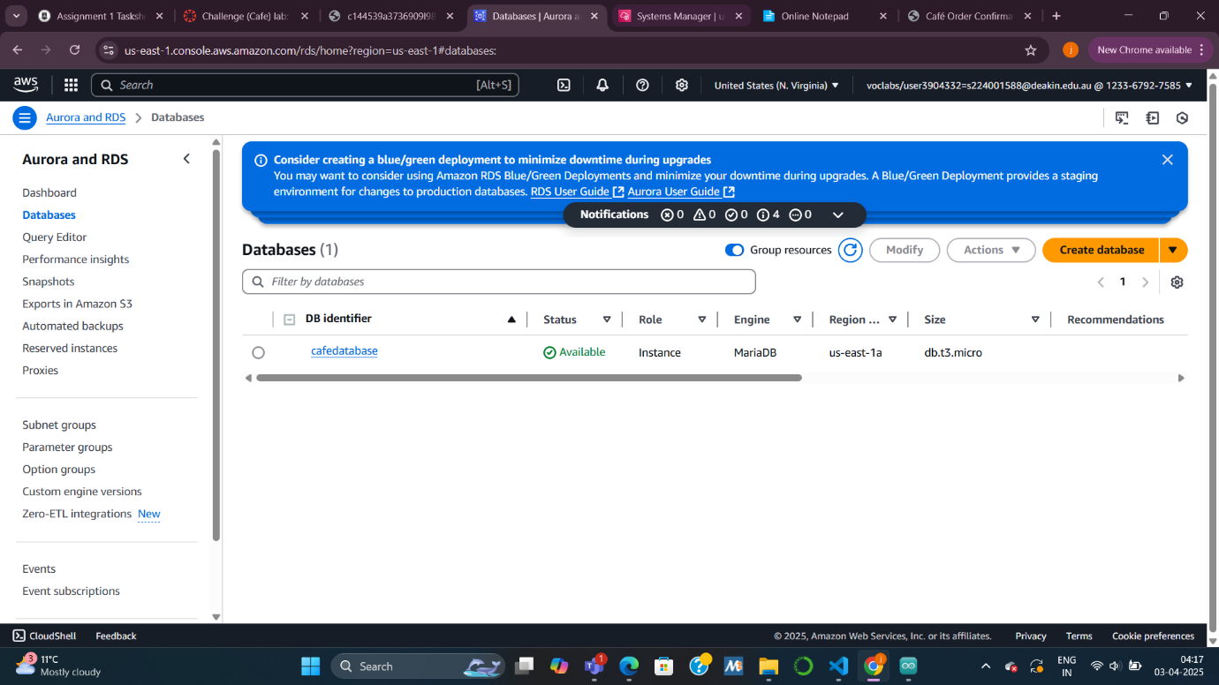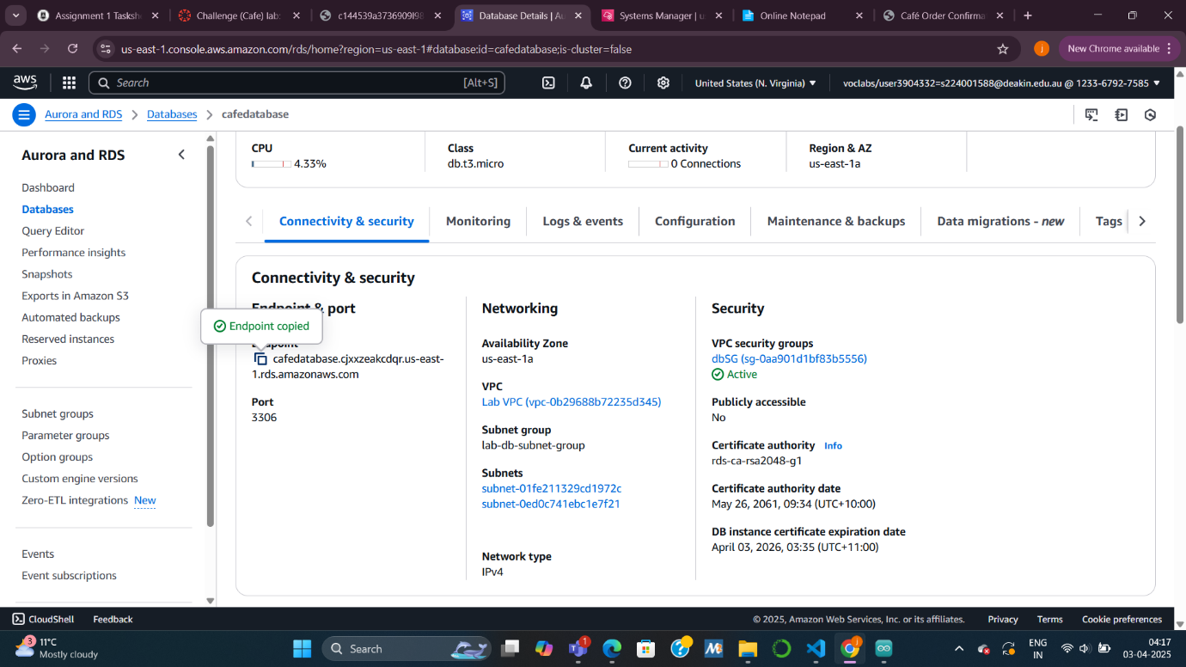

***Task 5: Importing data into RDS***

***Summary:  
I imported the previously exported SQL data file into the new RDS MariaDB instance, then verified that all café order data was restored successfully.***

***Explanation:  
We ran a command to import the contents of CafeDbDump.sql into the RDS instance. After importing, I logged into the RDS database and used SQL queries to confirm the presence of the cafe_db, including tables like order and order_item. The data matched what we had exported, indicating a successful migration.***

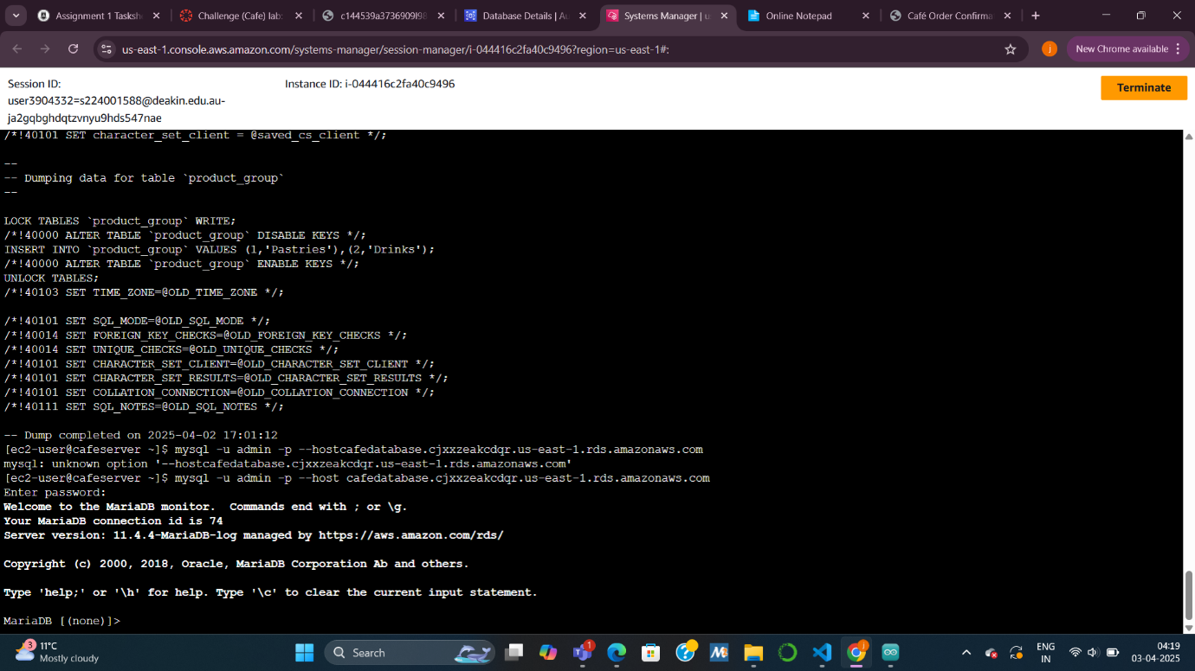

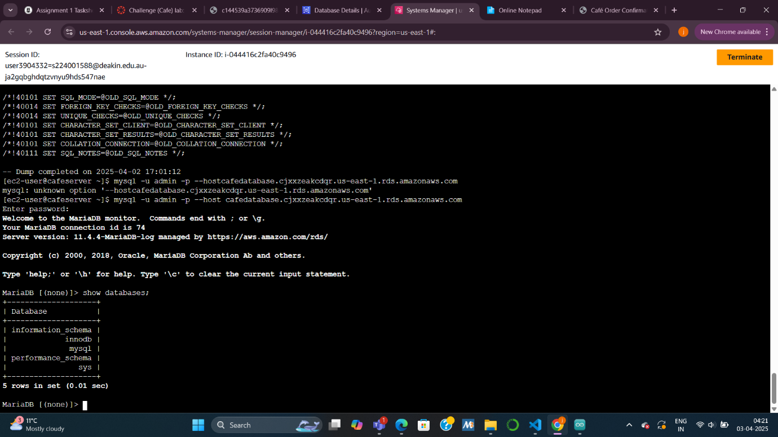

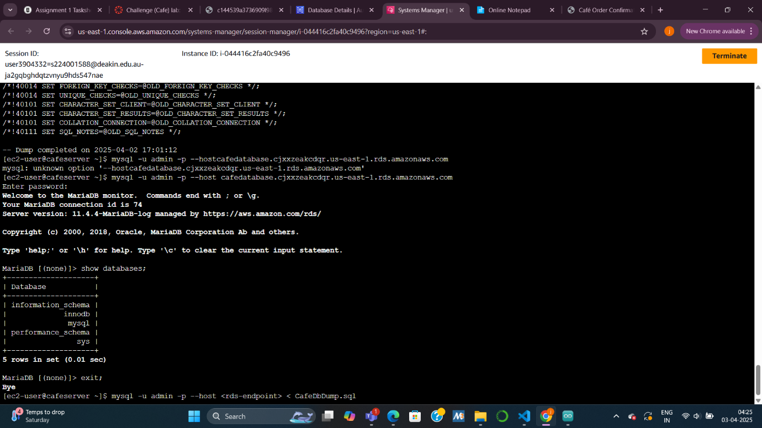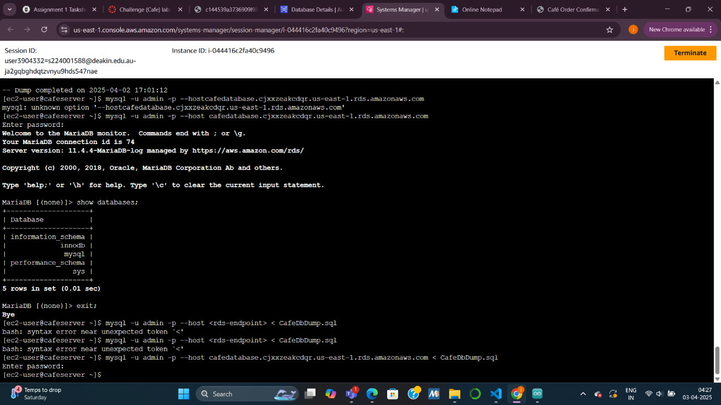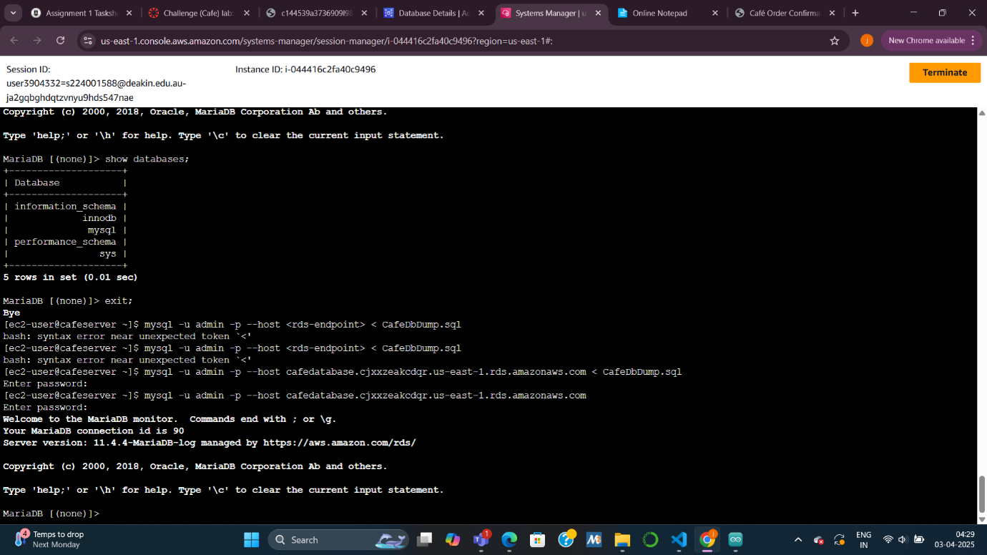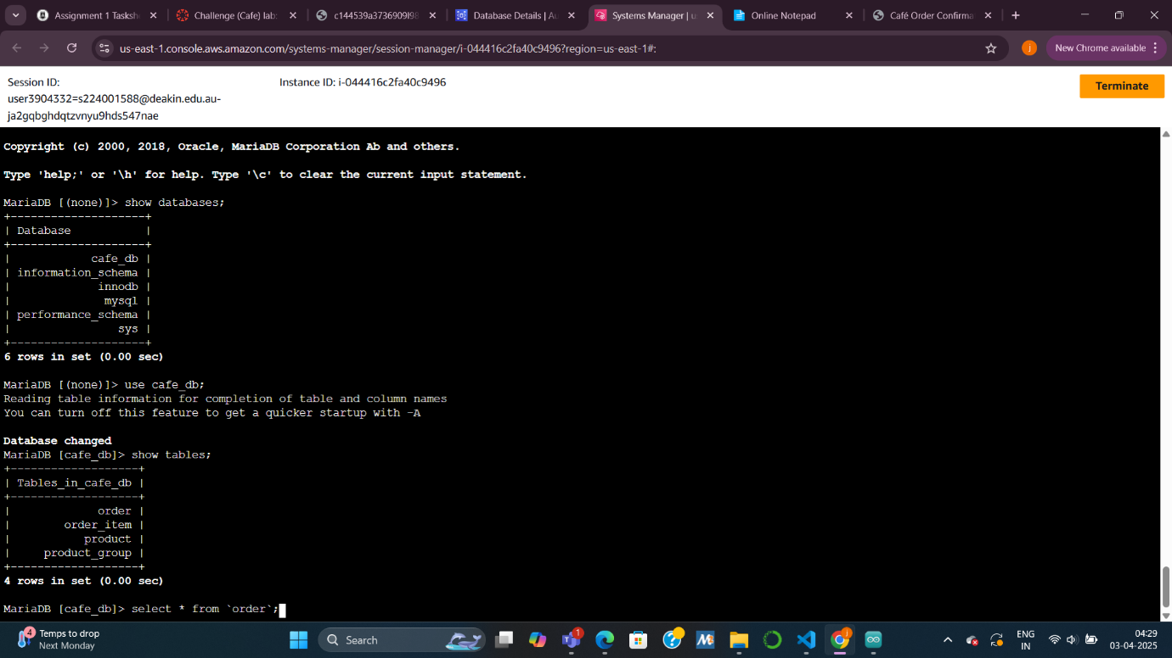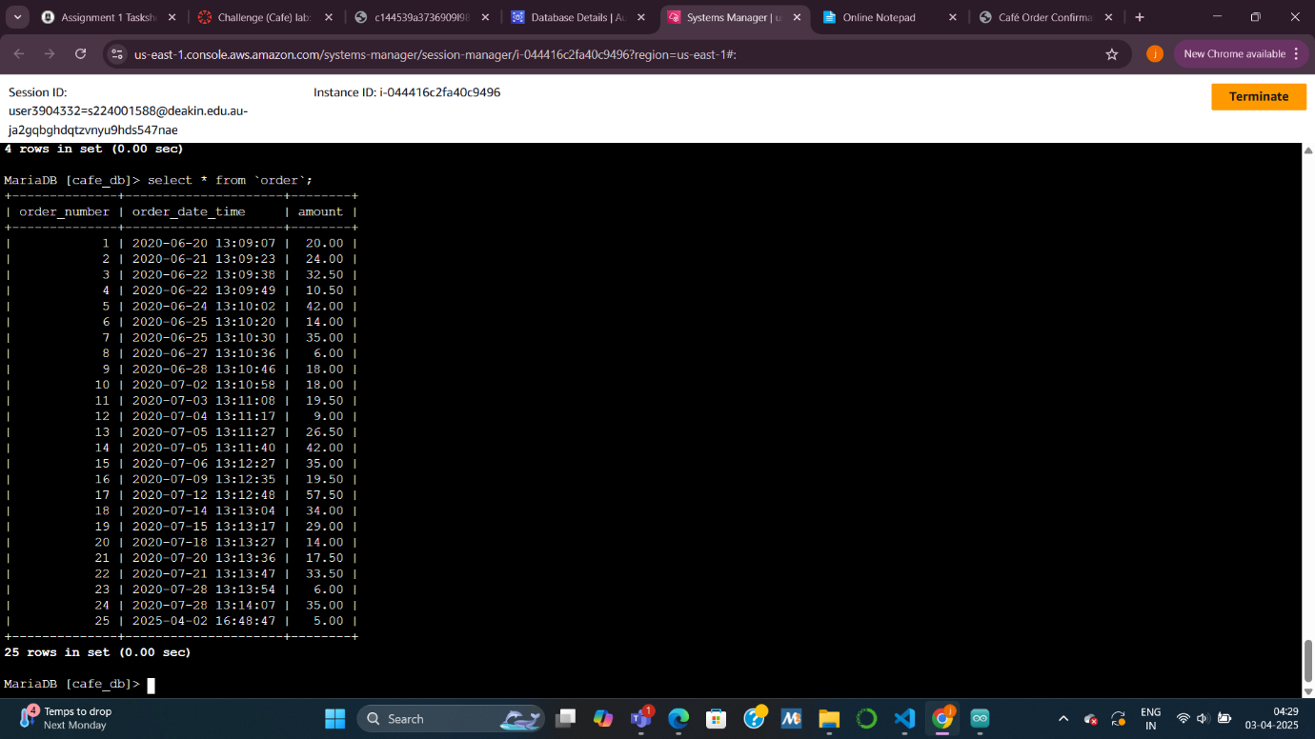

***Task 6: Connecting the café application to the new database***

***Summary:  
I updated the café web application to use the RDS instance instead of the local database, and confirmed that the app still works by placing a new order and viewing order history.***

***Explanation:  
We updated the database endpoint stored in AWS Secrets Manager so the application would point to the RDS database. I then stopped the local MariaDB service on the EC2 instance to avoid any accidental usage. Finally, I tested the app again by placing an order and confirmed that the data was saved and retrieved from the RDS instance.***

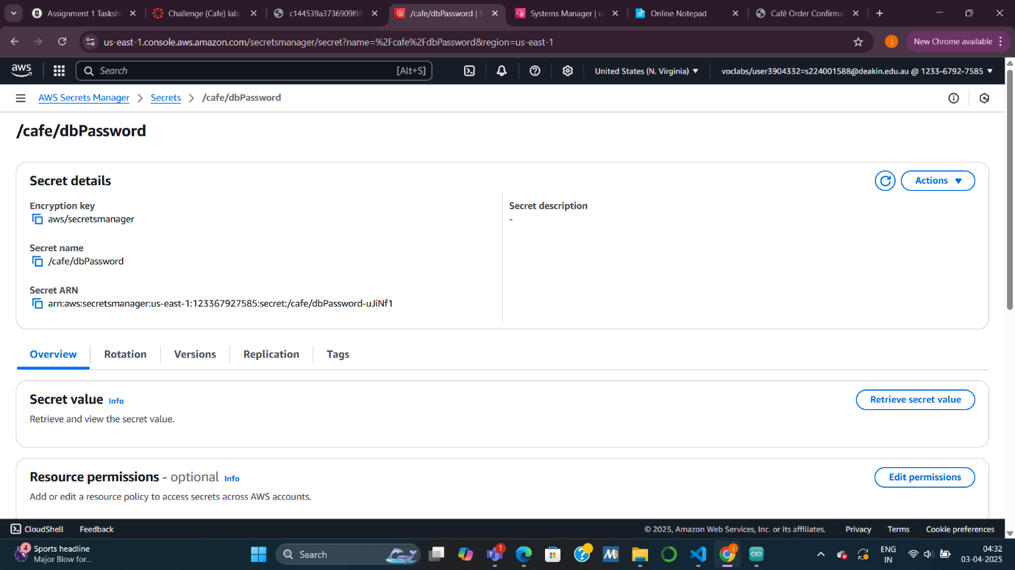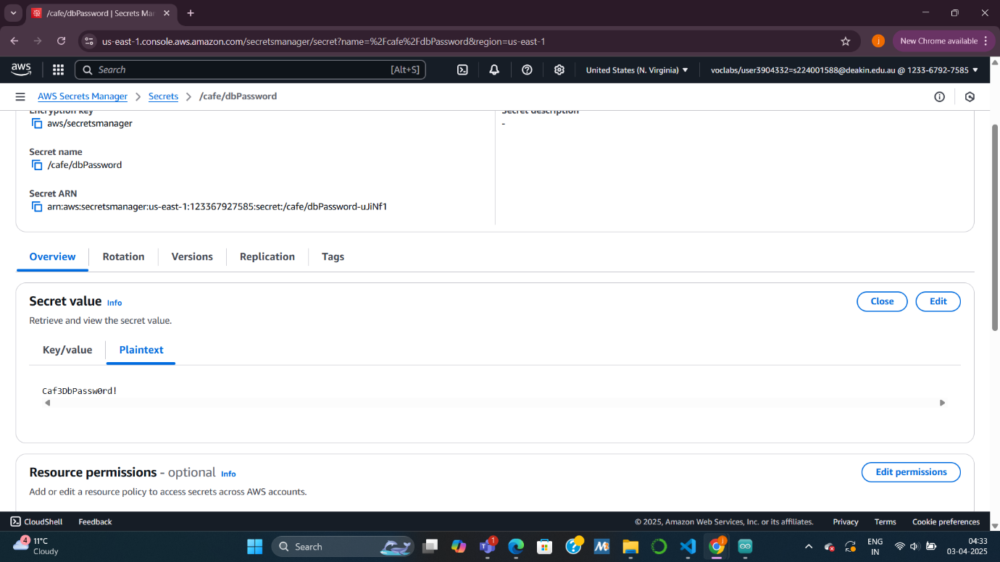

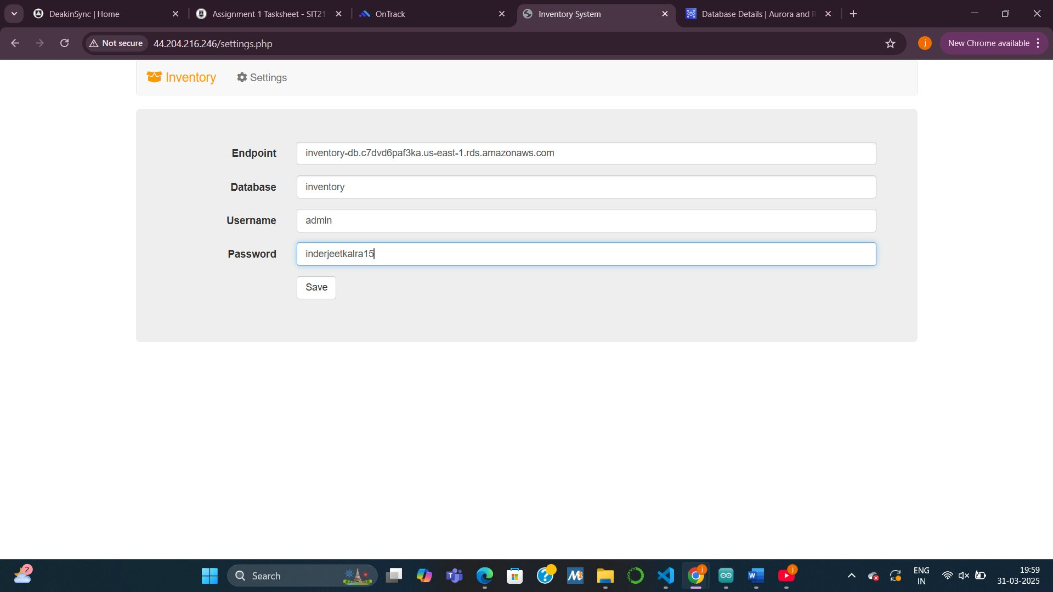

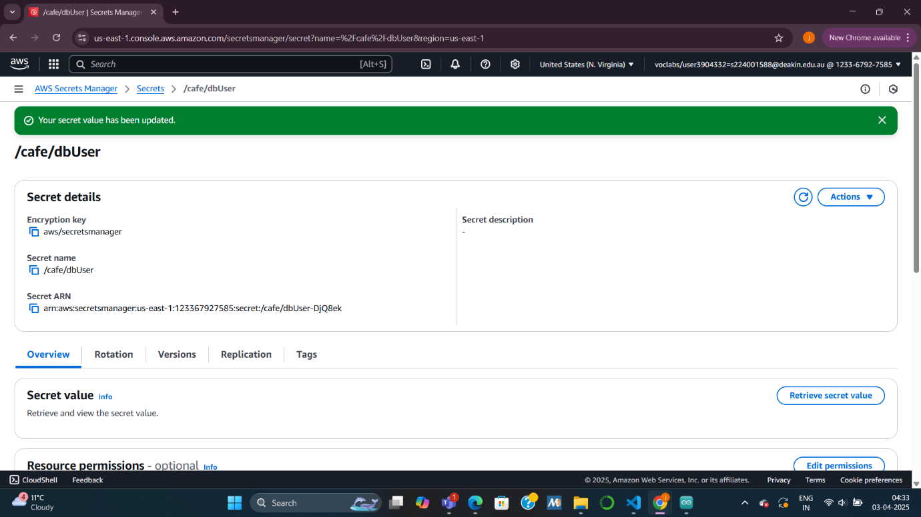

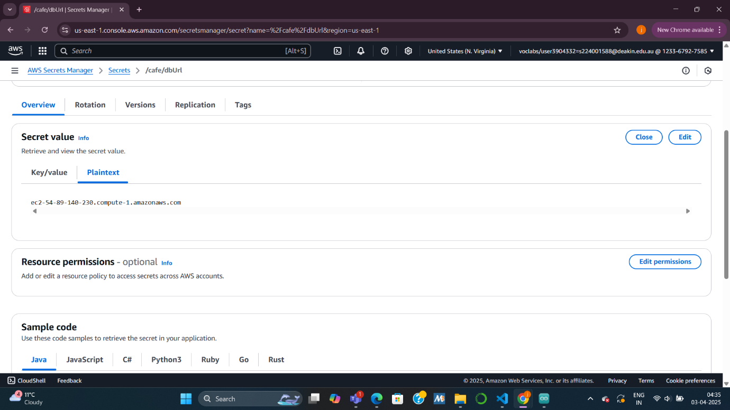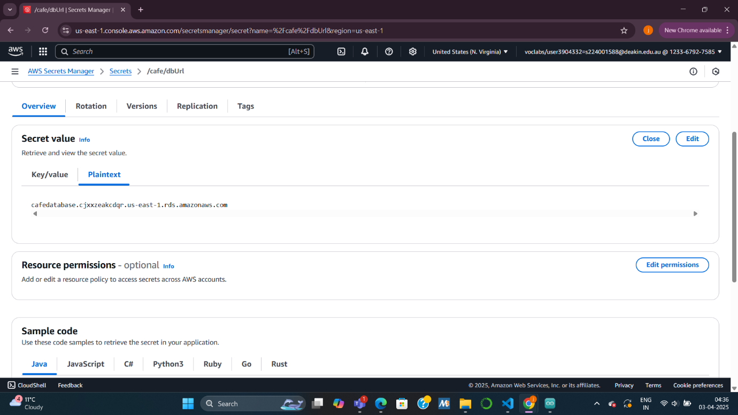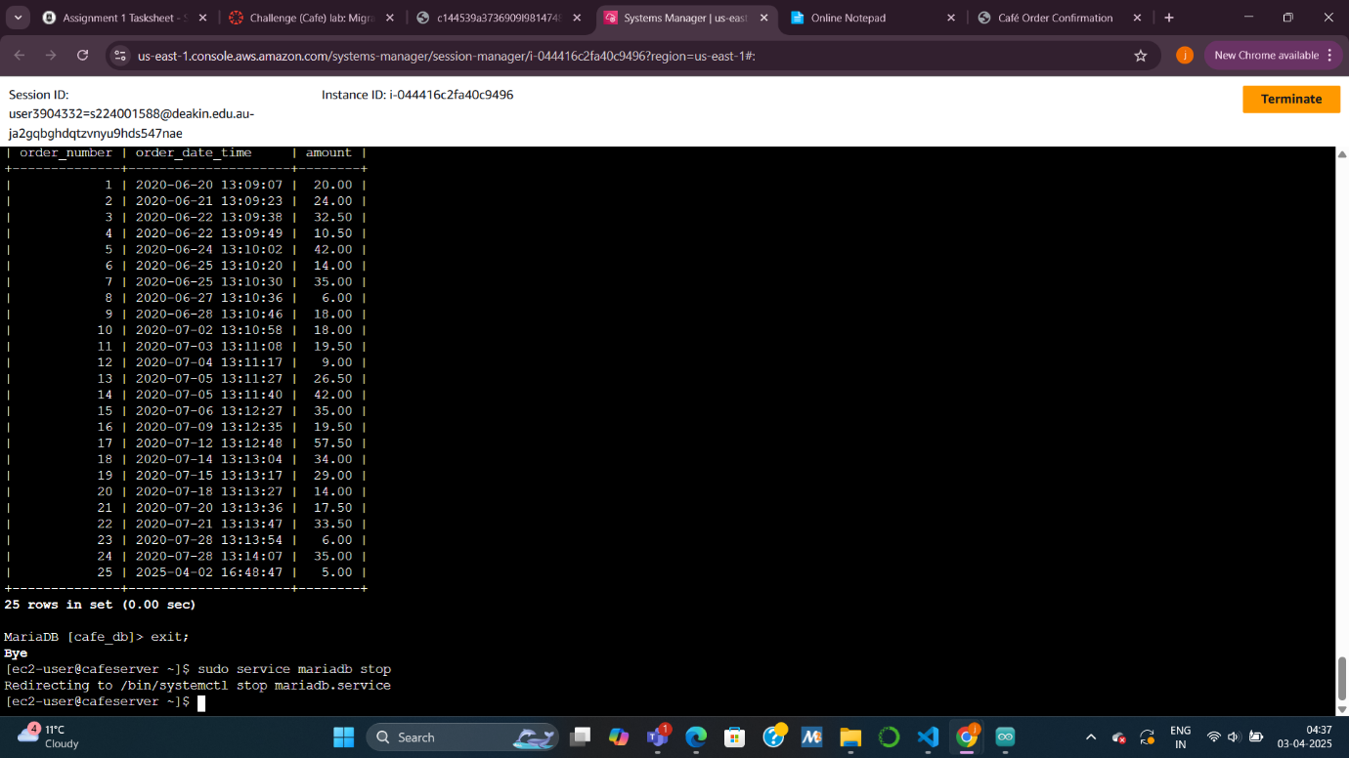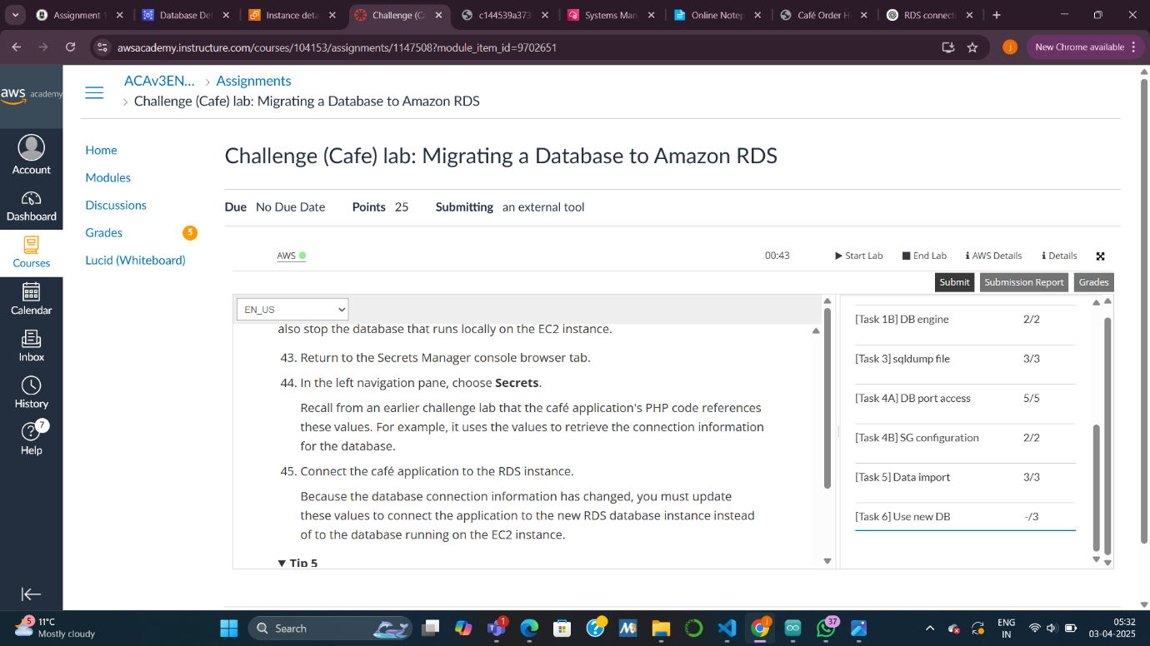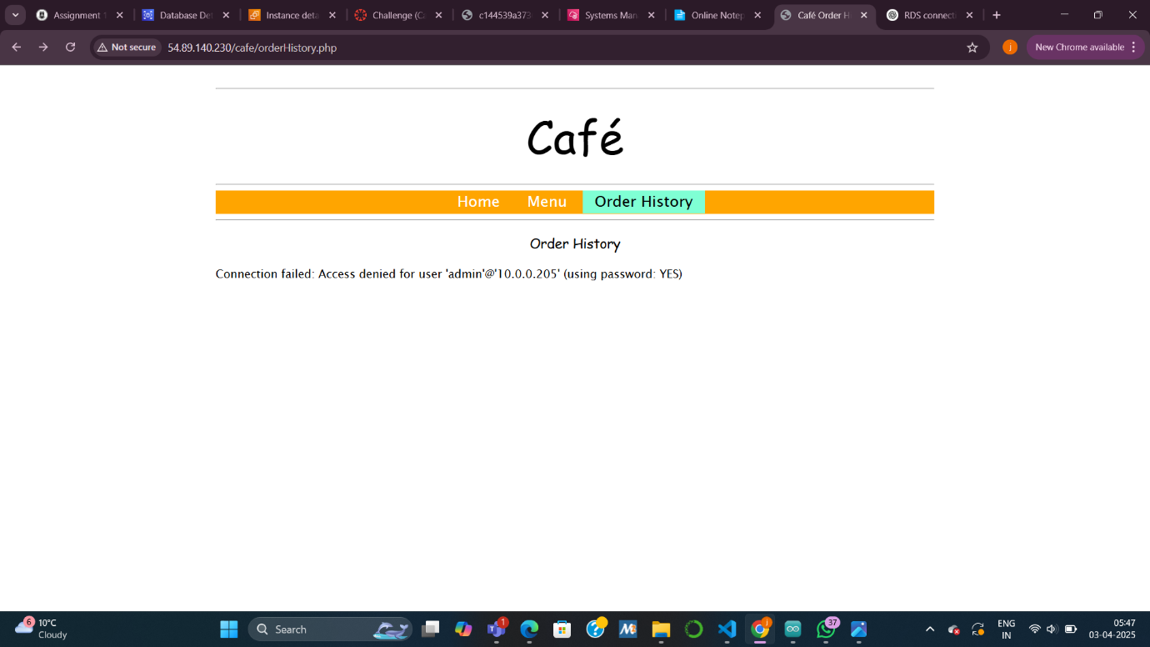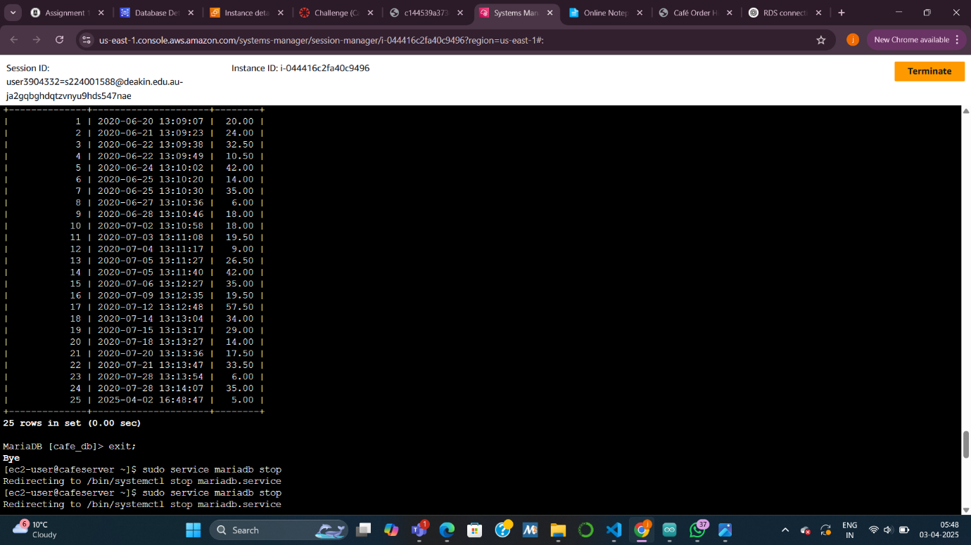

***Task 6 – not working successfully***

***Explaination***

***Even though I updated the Secrets Manager values, stopped the local MariaDB service, and restarted the web server, the café application still failed to connect to the RDS instance. This suggests a network connectivity issue between the EC2 instance and the RDS database.***

***RDS instances are placed in a VPC, and their connectivity is controlled through subnets and security groups. If the RDS security group (e.g., dbSG) does not allow inbound MySQL traffic (port 3306) from the EC2 instance, the connection attempt will silently fail — and the application will not be able to access the database.***

***How do I rectify it :***

***Make sure that I am connected to a well connected internet connection.***

***Make sure that ive completed all the steps.***

***Make sure ive added appropriate inbound rules.***

***Questions :***

***. Where is the RDS instance running?***

***How to find it:  
Go to the Amazon RDS Console → Click on your instance CafeDatabase → Under Connectivity & security, check the Availability Zone (AZ) or Region.***

***Example Answer:  
The RDS instance is running in the us-east-1a Availability Zone, within the Lab VPC.***

***. Does the RDS instance have an IPv4 public IP address assigned to it?***

***How to find it:  
Still in the Connectivity & security tab, look under Network & security → check the Public access setting.***

***Example Answer:  
No, the RDS instance does not have an IPv4 public IP address assigned to it. Public access is disabled.***

***. What is the Name tag applied to the subnet in which the RDS instance is running?***

* ***How to find it:  
  From the RDS instance details, note the subnet ID.  
  Then go to the VPC Console → Subnets → Search for that subnet ID, and view the "Name" tag.***
* ***Example Answer:  
  The Name tag applied to the subnet is private-subnet-a (replace with the actual name you see).***

***. How many security group rules are defined for the RDS instance***

* ***How to find it:  
  From the RDS instance page → Under Connectivity & security, find the Security group (dbSG) → Click it → Count the Inbound and Outbound rules.***
* ***Example Answer:  
  The RDS instance has 1 inbound rule and 1 outbound rule defined in its security group.***